Computer project

Name:-
Reg num:-

Topic:-

GYM MANAGEMENT SYSTEM

TABLE OF CONTENTS

- Introduction.
  - Introduction of the Project.
  - Objectives Of The Project.

- System Analysis
  - Identification Of The Need
  - Preliminary Investigation
  - Feasibility Study
    - Technical Feasibility
    - Economical Feasibility
    - Operational Feasibility
  - Proposed System Functionality

- Software Engineering Paradigm Applied

- Software Project Development Methodology.

- Design
  - Data Flow Diagram (DFD)
  - Database Design
  - Entity Relationship Diagram

- Source Code

- Screen Layouts

- Testing

- Implementation

- Maintenance

- Conclusion

- Bibliography

SECTION 1

INTRODUCTION

1.1 Introduction to the Project

1.2 Objectives Of The Project

INTRODUCTION TO THE PROJECT

This project is designed to facilitate a gymming and fitness center to automate its operations of keeping records and store them in form of a large and user friendly database further facilitating easy access to the personnel.

OBJECTIVES OF THE PROJECT

What was the Problem?

- Existing system was manual.

- Time consuming as data entry which include calculations took lot of time.

- Searching was very complex as there could be 100’s of entry every year.

- The proposed system is expected to be faster than the existing system.

- The Project was made in order to effectively and efficiently cater to requirements of the fitness center.Very frequently the person who generally holds the tasks to manage the center needs to keep records of all the transactions as well as data mannually . Gennerally, In order to structure these tasks Separate Registers are maintained.This whole process thus becomes quite cumbersome for them to control manually.Moreover,Any wrong data entered mistakenly can brings serious results.

- This Mannually Managed system of the store was also heavily proned to data loss due to certain causes Misplacement of Registers,Destruction of Registers ,Unauthorized access to registers etc. which can bring in disasterous Consquences.

- The cost of maintaince of data and records of occurrence of transactions is very high.

- Searching a particular data specific to particular requirements is also very tedious in such system.In order to retrieve records,The responsible person needs to manually locate the appropriate register and locate the appropriate placement of that particular record which may be very time consuming.

- Data Redundency is also a great issue in such kind of system.”Redundency” means repititon;Thus data modified or updated at a particular place may not be data modified or updated at the other related place which may create inconsistencies in data handling,Destroys Data Integrity and creates confusion for the owner.
- What the Software Provides in this Regard?
- The software is capable enough to allow the concerned person to store and retrieve any type of record with just a single click of mouse.The software allows Interactive ,Self decribing Graphic User Interface environment where even standalone users can work very comfortably and easily.

- All the data pertaining to transactions or other important entities is kept at central database from where its attributes can be easily controlled.But,Such kind of technical details are hidden from the standalone User. He just needs to type in correct details of the given entity and then click the save button with the help of mouse.However,That central repository of data can be easily accessed if required.

- Data Redundency is no more the problem now.The data modified from one particular data entry form will reflect the modifications at the other related forms too.This has thus reduced the chances of data inconsistency in our data storage.

- There is no need to manage bulky registers now as data stored in the backend database can be radily retrieved either from the frontend form itself or directly from the database.

- Requires one time investment of setting up required Hardware and Software after which no more headache is required by the Managers.Moreover,It also reduces dependence on Man Power.

- Effective Search measures are present at each and every data transactional forms from where by just entering a Unique keyword for that data its whole records can be readily seen within microseconds.Moreover,Facillity of Updation and Deletion of data through search is also available.

SECTION 2

SYSTEM ANALYSIS

2.1 Identification Of The Need

2.2 Preliminary Investigation

2.3 Feasibility Study

2.3.1 Technical Feasibility

2.3.2 Economical Feasibility

2.3.3 Operational Feasibility

2.3.4 Behavioural Feasibility

2.4 Proposed System Functionality
System Analysis refers into the process of examining a situation with the intent of improving it through better procedures and methods. System Analysis is the process of planning a new System to either replace or complement an existing system. But before any planning is done the old system must be thoroughly understood and the requirements determined. System Analysis, is therefore, the process of gathering and interpreting facts, diagnosing problems and using the information to re-comment improvements in the System. Or in other words, System Analysis means a detailed explanation or description. Before computerized a system under consideration, it has to be analyzed. We need to study how it functions currently, what are the problems, and what are the requirements that the proposed system should meet.
System Analysis is conducted with the following objectives in mind:

- Identify the customer’s need.

- Evaluate the system concept for feasibility.

- Perform economic and technical analysis.

- Allocate functions to hardware, software people, database and other system elements.

- Establish cost and schedule constraints.

- Create a system definition that forms the foundation for all the subsequent engineering work.

2.1 Identification of Customer’s Need
Before proceding further ,It becomes very necessary to accumilate the valid and conviencing requirements of the project and communicate the very same to various stakeholders of the project.
This step is initiation of System Analysis. An overview of the client’s requirement has been done. The basic need of the client to opt for such kind of project is analysed. As per current marketing scenario, an entire system was required to track day-to-day transactions.
Client was following a Manual Process, which is not at all compatible with its current working conditions. It was not only time consuming, but also lacks accuracy. Security point of view the manual system was failed to hide the information from any unauthenticiated staff or any outside person. Therefore, there was an urgent requirement of such Computerised System which can fullfill all of its current as well as future requirements. Further more, data handling was also posing a serious problem for them.

2.2 Preliminary Investigation
The client set is just a worker(s),who is regularly indulged in manual maintainence transactions,keeping regular records,maintaining the records of fine details of members.
Following manual registers are maintained:

- Member’s Details Register:
This Register is maintained in liu to maintain the records of the various members of the gymming center.The document contains relevant information about the various members such as members’s id, Name,Address,Telephone number.

- Employee’s Details Register:
This Register is maintained in liu to maintain the records of the various employees of the gymming center.The document contains relevant information about the various employees such as employee’s id, Name,Address,Telephone number.

- Inventory Register:
The register is used to record the details of the products(supplements,beverages and apparels supplied and required) such as its ID,Description,Quantity,Price,service date,time period for which it is under maintainence etc.

2.3 Feasibilty Study
Depending on the results of the initial investigation, the survey is expanded to a more detailed feasibility study. Feasibility study is a test of system proposal according to its workability, impact on the organization, ability to meet user needs, and effective use of resources. The objective of the feasibility study is not to solve the problem but to acquire a sense of its scope . During the study, the problem definition is crystallized and aspects of the problem to be included in the system are determined. Consequently, costs and benefits are described with greater accuracy at this stage.
It consists of the following:

1. Statement of the problem:
A carefully worded statement of the problem that led to analysis.
2. Summary of finding and recommendations:
A list of the major findings and recommendations of the study. It is ideal for the user who requires quick access to the results of the analysis of the system under study. Conclusion are stated , followed by a list of the recommendation and a justification for them .
3. Details of findings :
An outline of the methods and procedures under-taken by the existing system, followed by coverage of the objectives and procedures of the candidate system. Included are also discussions of output reports, file structures, and costs and benefits of the candidate system.

4. Recommendations and conclusions:
Specific recommendations regarding the candidate system, including personnel assignments, costs, project schedules, and target dates.

2.3.1 Technical Feasibility
Technical feasibility centers around the existing computer system (Hardware and Software etc) and to what extend it support the proposed addition. For example, if the current computer is operating at 80 percent capacity - an arbitrary ceiling - then running another application could overload the system or require additional Hardware. This involves financial considerations to accommodate technical enhancements. If the budgets is a serious constraint ,then the project is judged not feasible. In this project, all the necessary cautions have been taken care to make it technically feasible. Using a key the display of text/object is very fast. Also, the tools, operating system and programming language used in this localization process is compatible with the existing one.

2.3.2 Economical Feasibility
Economic analysis is the most frequently used method for evaluating the effectiveness of the candidate system. More commonly known as cost/benefit analysis, the procedure is to be determining the benefits and savings that are expected from a candidate and compare them with costs. If benefits outweigh costs, then the decision is made to design and implement the system.

A systems financial benefit must exceed the cost of developing that system. i.e. a new system being developed should be a good investment for the organization. Economic feasibility considers the following:
i. The cost to conduct a full system investigation.
ii. The cost of hardware and software for the class of application.
iii. The benefits in the form of reduced cost or fewer costly errors.
iv. The cost if nothing changes (i.e. The proposed system is not developed).

The proposed SYSTEM is economically feasible because
i. The system requires very less time factors.
ii. The system will provide fast and efficient automated environment instead of slow and error prone manual system, thus reducing both time and man power spent in running the system.
iii. The system will have GUI interface and very less user training is required to learn it.
iv. The system will provide service to view various information if required for some decision making.

2.3.3 Operational Feasability
This Application is very easy to operate as it is made user friendly with the help of very effective GUI tools . Main consideration is user’s easy access to all the functionality of the Application.Another main consideration is here is that whether user organization is trained enough to use the newer application. Here every functionality is As per previous operational strategy which is not expected to be cumbersome to the potential clients.

2.3.4 Behavioural Feasibility

People are inherently resistant to change, and computers have been known to facilitate change. An estimate should be made of how strong a reaction the user staff is likely to have toward the development of a computerized system. Therefore it is understandable that the introduction of a candidate system requires special efforts to educate and train the staff.The software that is being developed is user friendly and easy to learn.In this way, the developed software is truly efficient and can work on any circumstances ,tradition ,locales.
Behavioral study strives on ensuring that the equilibrium of the organization and status quo in the organization are nor disturbed and changes are readily accepted by the users.

2.4 Proposed System Functionality

The proposed system will be designed to support the following features:-

- The proposed system has a user friendly Interface for porting of data to server.

- The proposed system provides the facility to pull the data from the server using a key (such as id) and get the desired report.

- The proposed system provides the no replication of data

SECTION 3

SOFTWARE ENGINEERING PARADIGM APPLIED
Software Engineering
The basic objective of software engineering is to: develop methods and procedures for software development that can scale up for large systems and that can be used to consistently produce high quality software at low cost and with a small cycle time. That is, the key objectives are consistency, low cost, high quality, small cycle time, and scalability.

The basic approach that software engineering takes is to separate the development process from the software. The premise is that the development process controls the quality, scalability, consistency, and productivity. Hence to satisfy the objectives, one must focus on the development process. Design of proper development process and their control is the primary goal of the software engineering. It is this focus on the process that distinguishes it from most other computing desciplines. Most other computing disciplines focus on some type of the product-algorithms, operating systems, databases etc. while software engineering focuses on the process for producing products. To better manage the development process and to achieve consistency, it is essential that the software development be done in phases.

Different Phases Of The Development Process:

- Requirement Analysis
Requirement analysis is done in order to understand the problem the software system is to solve. The problem could be automating an existing manual process, developing a new automated system, or a combination of the two. The amphasis in requirements analysis is on identifying what is needed from the system, not how the system will achieve its goals. There are atleast two parties involved in the software development-a client and a developer. The developer has to develop the system to satisfy the client’s needs. The developer does not understand the client’s problem domain, and the client does not understand the issues involved in the software systems. This causes a communication gap, which has to be adequately bridged during requirements analysis.

- Software Design
The purpose of the design phase is to plan a solution of the problem specified by the requirements documents. This phase is the first step in moving from the problem domain to the solution domain. Starting with what is needed, design takes us toward how to satisfy the needs. The design of a system is perhaps the most critical factor affecting the quality of the software. It has a major impact on the later phases, particularly testing and maintenance.
The design activity is divided into two phases: System Design and Detailed Design. In system design the focus is on identifying the modules, whereas during detailed design the focus is on designing the logic for each of the modules.

- Coding
The goal of the coding phase is to translate the design of the system into code in a given programming language. Hence during coding, the focus should be on developing programs that are easy to read and understand, and not simply on developing programs that are easy to write.

- Testing
Testing is the major quality control measure used during software development. Its basic function is to detect errors in the software. Testing not only uncover errors introduced during coding, but also errors introduced during the previous phases. Thus, the goal of the testing is to uncover requirement, design and coding errors in the programs. Therefore, different levels of testing are used. Testing is an extremely critical and time consuming activity. It requires proper planning of the overall testing process. The output of the testing phase is the test report and the error report. Test report contains the set of test cases and the result of executing the code with these test cases. The error report describes the errors encountered and the action taken to remove the errors.

- Implementation
It is the process of having systems personnel check out and put new equipment into use, train users, install the new application and construct any files of data needed to use it. This phase is less creative than system design. Depending on the size of the organization that will be involved in using the application and the risk involved in its use, systems developers may choose to test the operation in only one area of the firm with only one or two persons. Sometimes, they will run both old and new system in parallel way to compares the results.

Paradigm Applied

In this project,The Spiral Model is applied in order to provide rigid efficiency and functionality in the overall working style of the project.Moreover, In order to cater to new or modified requirements of the user, Spiral model is very effective .I used “The Spiral model” as it is best suited to those development environments where probability of uncertainity is very high and chances of mistakes are uncontrollable.

What about Spiral Model?
The spiral model is a software development process combining elements of both design and prototyping-in-stages, in an effort to combine advantages of top-down and bottom-up concepts. Also known as the spiral lifecycle model, it is a systems development method (SDM) used in information technology (IT). This model of development combines the features of the prototyping model and the waterfall model. The spiral model is intended for large, expensive and complicated projects.

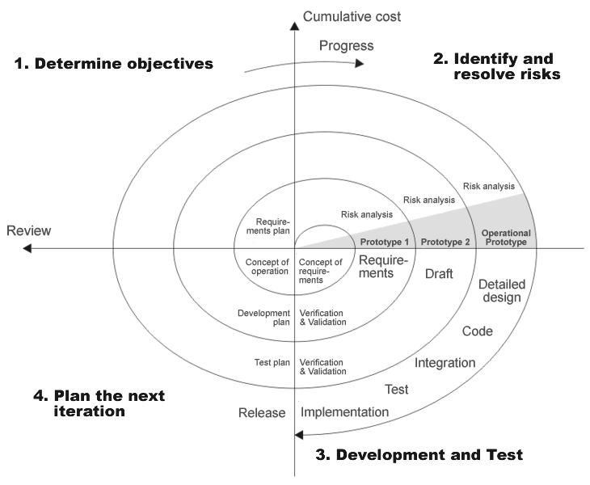

The steps in the spiral model can be generalized as follows:
- The new system requirements are defined in as much detail as possible. This usually involves interviewing a number of users representing all the external or internal users and other aspects of the existing system.
- A preliminary design is created for the new system.
- A first prototype of the new system is constructed from the preliminary design. This is usually a scaled-down system, and represents an approximation of the characteristics of the final product.
- A second prototype is evolved by a fourfold procedure:
  - Evaluating the first prototype in terms of its strengths, weaknesses, and risks;
  - Defining the requirements of the second prototype;
  - Planning and designing the second prototype;
  - Constructing and testing the second prototype.
- At the customer's option, the entire project can be aborted if the risk is deemed too great. Risk factors might involve development cost overruns, operating-cost miscalculation, or any other factor that could, in the customer's judgment, result in a less-than-satisfactory final product.
- The existing prototype is evaluated in the same manner as was the previous prototype, and, if necessary, another prototype is developed from it according to the fourfold procedure outlined above.
- The preceding steps are iterated until the customer is satisfied that the refined prototype represents the final product desired.
- The final system is constructed, based on the refined prototype.
- The final system is thoroughly evaluated and tested. Routine maintenance is carried out on a continuing basis to prevent large-scale failures and to minimize downtime.

Applications
The spiral model is used most often in large projects. For smaller projects, the concept of agile software development is becoming a viable alternative.
Advantages
- Estimates (i.e. budget, schedule, etc.) become more realistic as work progresses, because important issues are discovered earlier.
- It is more able to cope with the changes that software development generally entails. Software engineers can get their hands in and start working on the core of a project earlier.

SECTION 4

Software Project Development Methodology
The Methodology:
I was assigned the duty for developing a computerized system for a fitness center. The project time and resources were very limited . The optimum use of practical time neccessiates that every session and every activity is planned. For effective Planning ,Efficient Project Managerial skils are required,Efficiant skills then trace out best methodology to be used.
The methodology used by me includes the following things:

- Topic Understanding:
It is vital that the field of application as introduced in the project may be totally a new field. So as soon as the project was allocated to me, I carefully went through the project requirements to identify the requirements of the project.

- Modular Break –Up Of The System:
- Identify The Various Modules In The System.
- List Them In The Right Hierarchy.
- Identify Their Priority Of Development.

Different Modules In Computerised System

Modules – This project consists of different interfaces which will be accessed through a MDI (Multiple Document Interface) window. Different modules that makeup this system have already been a described in system analysis.

- Module 1: Member’s Module
In this module,Owner can see the membership details which includes:

- MEMBER DETAILS
- Member id
- Name
- Gender
- MEMBERSHIP DETAILS
- Membership type
- Expiration date
  - MEMBERSHIP DETAILS
- Address
- Date of birth
- Phone number
  - ACCOUNT INFORMATION
    - Due date
    - Amount Due
    - Amount Paid
    - Days late
    - Balance

After processing all this information records are saved and in this module itself there is a provision for report generation for viewing details of all the members.
There is also a provision for generating a receipt for an individual member thus agin giving some of his relevant details.

- Module 2:Employee’s Module
In this module owner can see the employee details including the fields:
- ID
- Name
- Gender
- Wage
- Address
- Date of birth
- Phone number
- Payroll calculation
- Pay date
- ID
- Name
- Hours worked
- Gross pay
- Tax
- Net pay
Along with this there is a provision for setting the schedule of the employees with information like time and day provided and the owner can view the schedule or even change it.

  - Module 3: Inventory module
It is further divided into three components:
  - INVENTORY
Gives description about a product based on its category and includes:
a.Category
b.Id
c.Description
d.Brand
e.Quantity
f.Date
  - ORDER
It facilitates the owner to place an order and based on the
category of the product(apparels,beverages,supplements)
following information is displayed along includin the
provision for order placement:
a.Category
b.Id
c.Description
d.Brand
e.Supplier
f.Number of cases
g.Quantity in each case
h.Case Price
i.Sales Price
j.Order Date
  - PRODUCTS
Generates an inventory record of the product based on the product category selected and displays the following information:

a.Category
b.Id
c.Description
d.Brand
e.Supplier
f.Number of cases
g.Quantity in each case
h.Quantity ordered
i.Case Price
j.Sales Price
k.Order Date
l.Last ordered
m.Last inventory
It also provides the facility of generating reports of all the products of a paticular category.

Principal Design Features

INTRODUCTION OF VISUAL BASIC

Visual Basic (VB) is a third-generation event-driven programming language and associated development environment (IDE) from Microsoft for its COM programming model. Visual Basic was derived from BASIC and enables the rapid application development (RAD) of graphical user interface (GUI) applications, access to databases using Data Access Objects DAO, Remote Data Objects RDO, or ActiveX Data Objects ADO and creation of ActiveX controls and objects. Scripting languages such as VBA and VBScript are syntactically similar to Visual Basic, but perform differently.
A programmer can put together an application using the components provided with Visual Basic itself. Programs written in Visual Basic can also use the Windows API, but doing so requires external function declarations.

Characteristics present in Visual Basic
Visual Basic has the following traits which differ from C-derived languages:
- Boolean constant True has numeric value −1.This is because the Boolean data type is stored as a 16-bit signed integer. In this construct −1 evaluates to 16 binary 1s (the Boolean value True), and 0 as 16 0s (the Boolean value False). This is apparent when performing a Not operation on a 16 bit signed integer value 0 which will return the integer value −1, in other words True = Not False. This inherent functionality becomes especially useful when performing logical operations on the individual bits of an integer such as And, Or, Xor and Not. This definition of True is also consistent with BASIC since the early 1970s Microsoft BASIC implementation and is also related to the characteristics of microprocessor instructions at the time.
- Logical and bitwise operators are unified. This is unlike all the C-derived languages (such as Java or Perl), which have separate logical and bitwise operators. This again is a traditional feature of BASIC.
- Variable array base. Arrays are declared by specifying the upper and lower bounds in a way similar to Pascal and Fortran. It is also possible to use the Option Base statement to set the default lower bound. Use of the Option Base statement can lead to confusion when reading Visual Basic code and is best avoided by always explicitly specifying the lower bound of the array. This lower bound is not limited to 0 or 1, because it can also be set by declaration. In this way, both the lower and upper bounds are programmable. In more subscript-limited languages, the lower bound of the array is not variable. This uncommon trait does exist in Visual Basic .NET but not in VBScript.
OPTION BASE was introduced by ANSI, with the standard for ANSI Minimal BASIC in the late 1970s.
- Relatively strong integration with the Windows operating system and the Component Object Model.
- Banker's rounding as the default behavior when converting real numbers to integers with the Round function.
- Integers are automatically promoted to reals in expressions involving the normal division operator (/) so that division of an odd integer by an even integer produces the intuitively correct result. There is a specific integer divide operator (\) which does truncate.
- By default, if a variable has not been declared or if no type declaration character is specified, the variable is of type Variant. However this can be changed with Deftype statements such as DefInt, DefBool, DefVar, DefObj, DefStr. There are 12 Deftype statements in total offered by Visual Basic 6.0. The default type may be overridden for a specific declaration by using a special suffix character on the variable name (# for Double, ! for Single, & for Long, % for Integer, $ for String, and @ for Currency) or using the key phrase As (type). VB can also be set in a mode that only explicitly declared variables can be used with the command Option Explicit.

INTRODUCTION OF Microsoft Access-2003
Microsoft Office Access, previously known as Microsoft Access, is a relational database management system from Microsoft that combines the relational Microsoft Jet Database Engine with a graphical user interface and software development tools. It is a member of the 2007 Microsoft Office system.
One of the benefits of Access from a programmer's perspective is its relative compatibility with SQL (structured query language) —queries may be viewed and edited as SQL statements, and SQL statements can be used directly in Macros and VBA Modules to manipulate Access tables. Users may mix and use both VBA and "Macros" for programming forms and logic and offers object-oriented possibilities.
MSDE (Microsoft SQL Server Desktop Engine) 2000, a mini-version of Microsoft SQL Server 2000, is included with the developer edition of Office XP and may be used with Access as an alternative to the Jet Database Engine.
Unlike a modern RDBMS, the Jet Engine implements database triggers and stored procedures in a non-standard way. Stored Procedures are implemented in VBA, and Triggers are only available from embedded Forms. Both Triggers and Stored procedures are only available to applications built completely within the Access database management system. Client applications built with VB or C++ are not able to access these features. Starting in Access 2000 (Jet 4.0), there is a new syntax for creating queries with parameters, in a way that looks like creating stored procedures, but these procedures are still limited to one statement per procedure.Microsoft Access does allow forms to contain code that is triggered as changes are made to the underlying table (as long as the modifications are done only with that form), and it is common to use pass-through queries and other techniques in Access to run stored procedures in RDBMSs that support these.
Why I Used Ms Access?
I used Ms Access because it is simply available in almost all the machines that is normally using Ms Office.
- The Ms Access is easily portable from one machine to other Machine.
- The MS Access has a good & Highly Interactive Graphic User Interface.
- MS Access is less costlier than other RDBMSs’ for small scale use.

SECTION 5

DESIGN

5.1 Data Flow Diagram (DFD)

5.2 DataBase Design

5.3 Entity Relationship Diagram

5.1 DATA FLOW DIAGRAM (DFD)
DFD is a model, which gives the insight into the information domain and functional domain at the same time. DFD is refined into different levels. The more refined DFD is, more details of the system are incorporated. In the process of creating a DFD, we decompose the system into different functional subsystems. The DFD refinement results in a corresponding refinement of data.
Following is the DFD of the “Proposed System”. We have refined the system up to two levels. Each break-up has been numbered as per the rule of DFD. We have tried to incorporate all the details of the system but there is some chance of further improvisation because of the study that is still going on for the project development.

Context Level or Zero Level DFD
This level shows the overall context of the system and it's operating environment and shows the whole system as just one process.

The Context Diagram or the Zero Level DFD.

Member details
Database Operations on MEMBERS record

GYM CENTER’S RECORD MANAGEMEN-T SYSTEM
Member list

Database Operations on EMPLOYEES record
Member’s Record
Reciept

Database Operations on INVENTIRY record

Employee details

Employee schedule

IInventory(orders and products)

5.2 DATABASE DESIGN

Introduction
- Database
A Database is the systematic collection of logically related Data with some inherent purpose to access and operate on various different data stored in the form of records so as to raise the ease and esfficiancy in data Handelling.

- Relational database
It is one which works upon the specification of relational model which is a database model based on first-order predicate logic, first formulated and proposed in 1969 by Edgar Codd.
Its core idea is to describe a database as a collection of predicates over a finite set of predicate variables, describing constraints on the possible values and combinations of values. The content of the database at any given time is a finite model (logic) of the database, i.e. a set of relations, one per predicate variable, such that all predicates are satisfied. A request for information from the database (a database query) is also a predicate.
The purpose of the relational model is to provide a declarative method for specifying data and queries: we directly state what information the database contains and what information we want from it, and let the database management system software take care of describing data structures for storing the data and retrieval procedures for getting queries answered.

- Database Tables

A table is a set of data elements (values) that is organized using a model of vertical columns (which are identified by their name) and horizontal rows. A table has a specified number of columns, but can have any number of rows.

List of Tables in Database:

Name of Database is “Gym_members.mdb”
Table 1: LOGIN VALUES

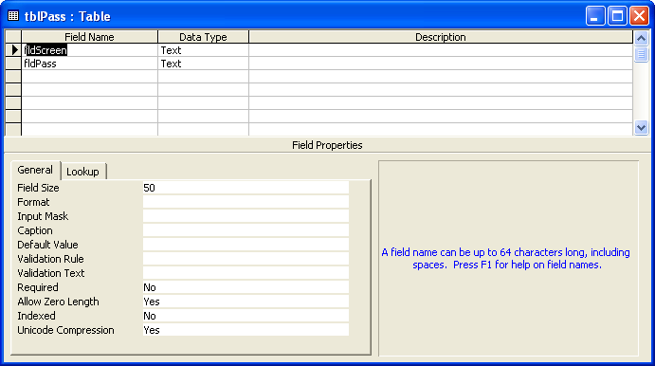

Table 2: MEMBER DETAILS

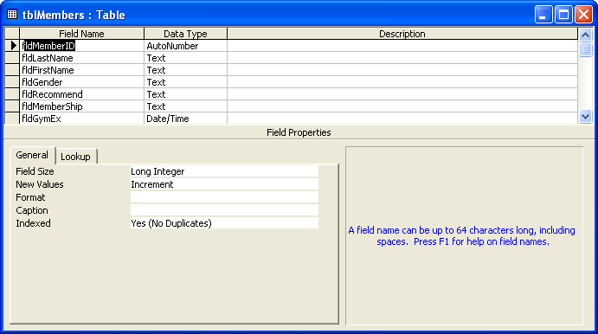
Table 3: RECIEPT GENERATION

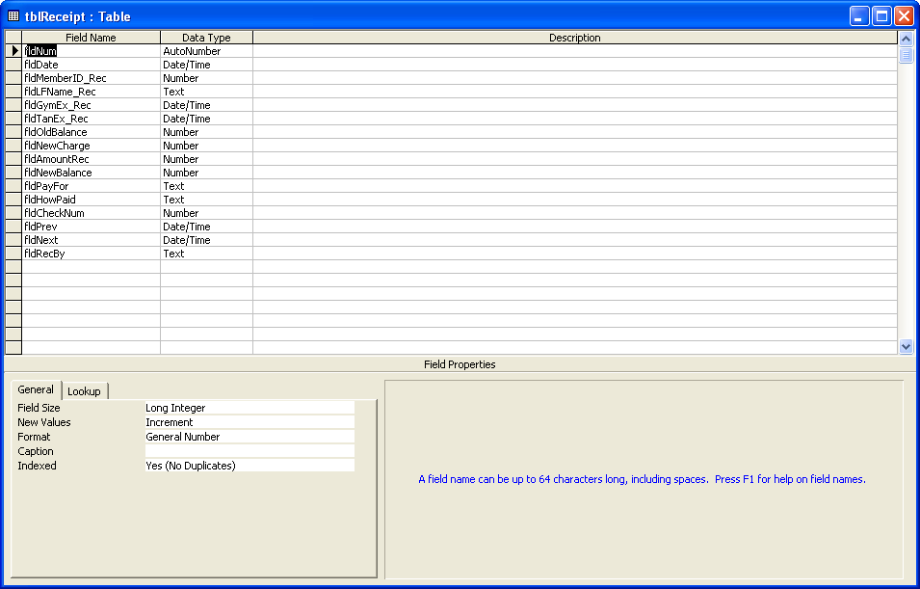

Table 4: EMPLOYEE DETAILS

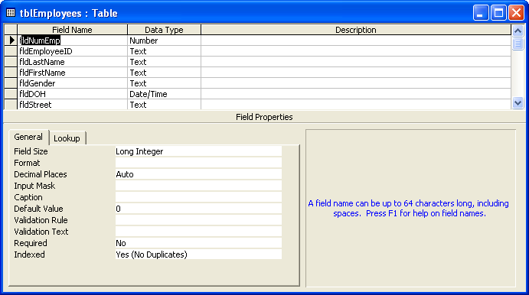

Table 5: EMPLOYEE PAYROLL

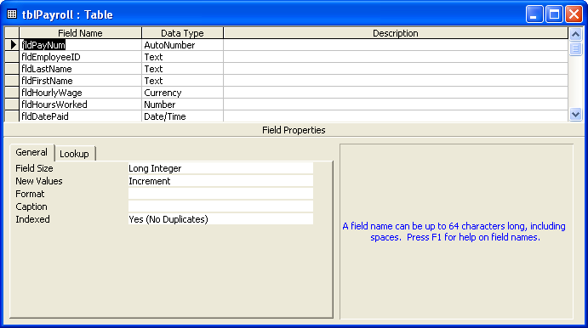

Table 6: EMPLOYEE SCHEDULE

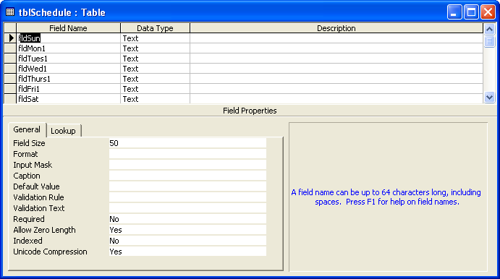
Table 7: INVENTORY TABLE

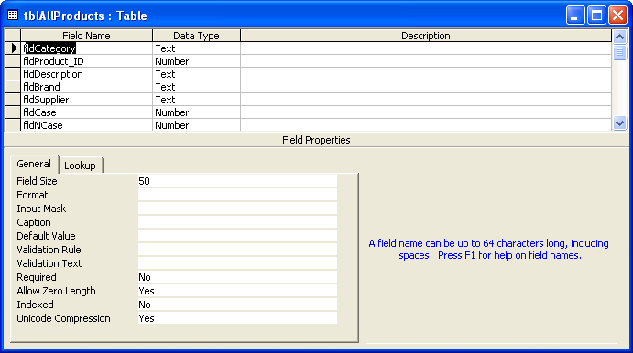
5.3 ENTITY-RELATIONSHIP DIAGRAM

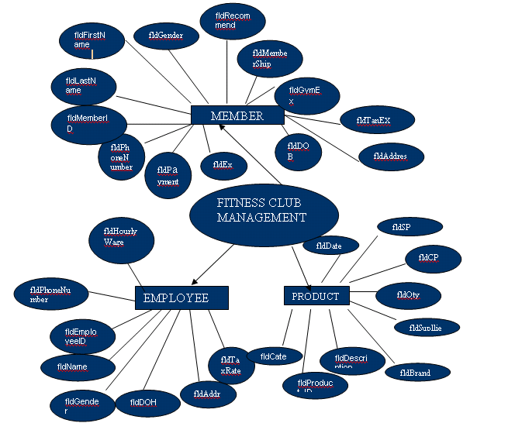

SECTION 6

SOURCE CODE
#SPLASH FORM
Option Explicit
Dim mintCount As Integer, mintPause As Integer

Private Sub tmrCount_Timer()

mintPause = mintPause + 1

If mintCount < 50 Then
mintCount = mintCount + 1
lblCount.Caption = "(" & mintCount & "%)..."
frmSplash.Refresh
ElseIf mintCount < 100 Then
mintCount = mintCount + 2
lblCount.Caption = "(" & mintCount & "%)..."
frmSplash.Refresh
End If

If mintPause = 101 Then
lblCount.Caption = "App..."
lblInform.Caption = "Starting"
ElseIf mintPause > 150 Then
Unload Me
frmPassword.Show
mdiDtcc.Show
End If

End Sub
#LOGIN FORM

Option Explicit
Dim mintctr As Integer
Dim mrstLogin As Recordset

Private Sub cboName_LostFocus()
txtPassword.Text = ""
End Sub

Private Sub cmdOn_Click()
Dim flag As Boolean
Dim xText
flag = False

If txtPassword.Text = "" Then
MsgBox "Please Enter Password", vbOKOnly + vbCritical, _
"Warning:End-User"
txtPassword.SetFocus
flag = True
End If

If cboName.ListIndex = 0 Then
If cboName = mrstLogin![fldScreen] And txtPassword = mrstLogin![fldPass] Then
mdiDtcc.tbrChoices.Visible = True
mdiDtcc.mnuMembers = True
mdiDtcc.mnuEmp = True
mdiDtcc.mnuInv = True
mdiDtcc.mnuChUser.Enabled = True
Unload Me
mdiDtcc.mnuOn.Visible = False
flag = True
gblnPriv = True
mdiDtcc.ToolCenter
frmTools.Show
frmTools.stb1.Tab = 0
End If
Else
mrstLogin.MoveNext
If cboName = mrstLogin![fldScreen] And txtPassword = mrstLogin![fldPass] Then
mdiDtcc.tbrChoices.Visible = True
mdiDtcc.mnuChUser.Enabled = True
mdiDtcc.mnuMembers = True
mdiDtcc.mnuEmp = True
mdiDtcc.mnuInv = True
Unload Me
mdiDtcc.mnuOn.Visible = False
flag = True
gblnPriv = False
End If
mrstLogin.MoveFirst
End If

If flag = False Then
mintctr = mintctr + 1
If mintctr = 4 Then
End
Else
xText = "You have" + Str(4 - mintctr) + " tries left"
If mintctr = 3 Then
xText = "This is your last chance!!"
End If
MsgBox "Access Denied!!" & vbCrLf & _
xText, vbOKOnly + vbCritical, "Warning:End-User"
txtPassword.Text = ""
End If
End If
End Sub

Private Sub Form_Load()

Dim pdbEnter As Database

Set pdbEnter = OpenDatabase(App.Path & "\Gym_Members.mdb")
Set mrstLogin = pdbEnter.OpenRecordset("tblPass")

mdiDtcc.tbrChoices.Visible = False
mdiDtcc.mnuScreen.Enabled = False
mdiDtcc.mnuChUser.Enabled = False
mdiDtcc.mnuMembers = False
mdiDtcc.mnuEmp = False
mdiDtcc.mnuInv = False
cboName = mrstLogin![fldScreen]
mintctr = 0
End Sub

Private Sub Form_Unload(Cancel As Integer)
mdiDtcc.mnuScreen.Enabled = True
End Sub
#MDI FORM

Option Explicit

Private Sub MDIForm_Load()
frmPassword.Top = mdiDtcc.ScaleHeight / 1.5
frmPassword.Left = mdiDtcc.ScaleWidth / 3.3
End Sub

Private Sub mnuAbout_Click()
frmAbout.Top = mdiDtcc.ScaleHeight / 5
frmAbout.Left = mdiDtcc.ScaleWidth / 4
frmAbout.Show
End Sub

Private Sub mnuCas_Click()
mdiDtcc.Arrange vbCascade
End Sub

Private Sub mnuChUser_Click()
Dim pstrUser As String
pstrUser = MsgBox("Change User?", vbYesNo + vbQuestion)

If pstrUser = vbYes Then
CloseForms
mnuOn.Visible = True
frmPassword.Show
frmPassword.Top = mdiDtcc.ScaleHeight / 4
frmPassword.Left = mdiDtcc.ScaleWidth / 4
End If
End Sub

Private Sub mnuEmp_Click()
ToolCenter
frmTools.Show
frmTools.stb1.Tab = 1
End Sub

Private Sub mnuExit_Click()
Unload Me
End Sub

Private Sub mnuIcons_Click()
mdiDtcc.Arrange vbArrangeIcons
End Sub

Private Sub mnuInv_Click()
ToolCenter
frmTools.Show
frmTools.stb1.Tab = 2
End Sub

Private Sub mnuMembers_Click()
ToolCenter
frmTools.Show
frmTools.stb1.Tab = 0
End Sub

Private Sub mnuScreen_Click()
frmPassword.Show
frmPassword.Top = mdiDtcc.ScaleHeight / 4
frmPassword.Left = mdiDtcc.ScaleWidth / 5
End Sub

Private Sub mnuThor_Click()
mdiDtcc.Arrange vbTileHorizontal
End Sub

Private Sub mnuTvert_Click()
mdiDtcc.Arrange vbTileVertical
End Sub

Private Sub tbrChoices_ButtonClick(ByVal Button As MSComctlLib.Button)
Select Case Button.Key
Case "Members"
ToolCenter
frmTools.Show
frmTools.stb1.Tab = 0
Case "Employees"
ToolCenter
frmTools.Show
frmTools.stb1.Tab = 1
Case "Inventory"
ToolCenter
frmTools.Show
frmTools.stb1.Tab = 2
End Select
End Sub

Public Sub CloseForms()
Unload frmAbout
Unload frmAllPro
Unload frmCal
Unload frmGym
Unload frmInventory
Unload frmNewEmp
Unload frmOrders
Unload frmPayroll
Unload frmProducts
Unload frmReceipt
Unload frmSchedule
Unload frmTools
End Sub

Public Sub ToolCenter()
If frmTools.WindowState <> vbMinimized Then
frmTools.Top = mdiDtcc.ScaleHeight / 4
frmTools.Left = mdiDtcc.ScaleWidth / 3
End If
End Sub
#MENU FORM
Private Sub cmdAllMem_Click()
If frmAllMem.WindowState <> vbMinimized Then
frmAllMem.Top = mdiDtcc.ScaleHeight / 20
frmAllMem.Left = mdiDtcc.ScaleWidth / 8
End If
frmAllMem.Show
End Sub

Private Sub cmdEmployees_Click()

If gblnPriv = True Then
If frmNewEmp.WindowState <> vbMinimized Then
frmNewEmp.Top = mdiDtcc.ScaleHeight / 8
frmNewEmp.Left = mdiDtcc.ScaleWidth / 8
End If
frmNewEmp.Show
ElseIf gblnPriv = False Then
MsgBox "Master Access Only!!!", vbOKOnly + vbInformation
End If

End Sub

Private Sub cmdInvent_Click()
If gblnPriv = True Then
If frmInventory.WindowState <> vbMinimized Then
frmInventory.Top = mdiDtcc.ScaleHeight / 5
frmInventory.Left = mdiDtcc.ScaleWidth / 8
End If
frmInventory.Show
ElseIf gblnPriv = False Then
MsgBox "Master Access Only!!!", vbOKOnly + vbInformation
End If
End Sub

Private Sub cmdMembers_Click()
If frmGym.WindowState <> vbMinimized Then
frmGym.Top = mdiDtcc.ScaleHeight / 20
frmGym.Left = mdiDtcc.ScaleWidth / 8
End If
frmGym.Show
End Sub

Private Sub cmdOrder_Click()
If gblnPriv = True Then
If frmOrders.WindowState <> vbMinimized Then
frmOrders.Top = mdiDtcc.ScaleHeight / 5
frmOrders.Left = mdiDtcc.ScaleWidth / 8
End If
frmOrders.Show
ElseIf gblnPriv = False Then
MsgBox "Master Access Only!!!", vbOKOnly + vbInformation
End If
End Sub

Private Sub cmdProducts_Click()
If frmProducts.WindowState <> vbMinimized Then
frmProducts.Top = mdiDtcc.ScaleHeight / 8
frmProducts.Left = mdiDtcc.ScaleWidth / 8
End If
frmProducts.Show
End Sub

Private Sub cmdSchedule_Click()
If frmSchedule.WindowState <> vbMinimized Then
frmSchedule.Top = mdiDtcc.ScaleHeight / 70
frmSchedule.Left = mdiDtcc.ScaleWidth / 10
End If
frmSchedule.Show
End Sub

Private Sub cmdWorkouts_Click()
If frmAllRec.WindowState <> vbMinimized Then
frmAllRec.Top = mdiDtcc.ScaleHeight / 40
frmAllRec.Left = mdiDtcc.ScaleWidth / 10
End If
frmAllRec.Show
End Sub
#MEMBER DETAILS FORM
Option Explicit
Dim flag As Integer
Dim mblnBrow As Boolean
Dim mintClear As Integer
Dim mintFind As Integer
Dim mblnCheck As Boolean
Dim mdatGExp As Date
Dim mdatTExp As Date
Dim mdatOD As Date
Dim mintOD As Integer
Dim mblnExpOD As Boolean

Private Sub cmdBrowse_Click()
If mblnBrow = True Then Form_Load
End Sub

Private Sub cmdExp_Click()
If mblnExpOD = True Then Form_Load

mrstGym.MoveFirst
Do Until mrstGym.EOF
If mrstGym!fldGExp = True Or mrstGym!fldTExp = True Then
mblnBrow = True
Set mrstGym = pdbMembers.OpenRecordset("SELECT * FROM tblMembers WHERE fldGExp = true or fldTExp=true ORDER BY fldMemberID")
ShowRecord
mintFind = 0
mblnExpOD = True
Exit Sub
Else
mrstGym.MoveNext
End If
Loop
MsgBox "No Expired Members!!!", vbOKOnly + vbInformation
Form_Load
End Sub

Private Sub cmdFind_Click()
mintClear = 1
mintFind = 1
txtId.SetFocus
ClearRecord
Set mrstGym = pdbMembers.OpenRecordset("SELECT * FROM tblMembers ORDER BY fldMemberID")
End Sub

Private Sub cmdOD_Click()
If mblnExpOD = True Then Form_Load

mrstGym.MoveFirst
Do Until mrstGym.EOF
If mrstGym!fldOD = True Then
mblnBrow = True
Set mrstGym = pdbMembers.OpenRecordset("SELECT * FROM tblMembers WHERE fldOD = true ORDER BY fldMemberID")
ShowRecord
mintFind = 0
mblnExpOD = True
Exit Sub
Else
mrstGym.MoveNext
End If
Loop
MsgBox "No Overdue Members!!!", vbOKOnly + vbInformation
Form_Load
End Sub

Private Sub cmdRecFile_Click()
gblnRec = True
If frmReceipt.WindowState <> vbMinimized Then
frmReceipt.Top = mdiDtcc.ScaleHeight / 5
frmReceipt.Left = mdiDtcc.ScaleWidth / 8
End If
frmReceipt.Show
End Sub

Private Sub cmdUpdate_Click()
Checktxt
If mblnCheck = False Then
WriteRecord
mrstGym.Update
Else
MsgBox "All Required!!", vbOKOnly + vbInformation
mblnCheck = False
End If
If flag = False Then ShowRecord
End Sub

Private Sub cmdEnter_Click()
mrstGym.AddNew
ClearRecord
txtLastName.SetFocus
flag = 1
End Sub

Private Sub cmdFirst_Click()
mrstGym.MoveFirst
ShowRecord
End Sub

Private Sub cmdLast_Click()
mrstGym.MoveLast
ShowRecord
End Sub

Private Sub cmdNewReceipt_Click()
gblnRec = False
If frmReceipt.WindowState <> vbMinimized Then
frmReceipt.Top = mdiDtcc.ScaleHeight / 5
frmReceipt.Left = mdiDtcc.ScaleWidth / 8
End If
frmReceipt.Show
End Sub

Private Sub mnuExit_Click()
Unload Me
End Sub

Private Sub cmdNext_Click()
mrstGym.MoveNext
If mrstGym.EOF Then mrstGym.MoveLast
ShowRecord
End Sub

Private Sub cmdPrev_Click()
mrstGym.MovePrevious
If mrstGym.BOF Then mrstGym.MoveFirst
ShowRecord
End Sub

Private Sub Form_Load()
Set pdbMembers = OpenDatabase(App.Path & "\Gym_Members.mdb")
Set mrstGym = pdbMembers.OpenRecordset("SELECT * FROM tblMembers ORDER BY fldMemberID")
mblnBrow = False
cmdFirst_Click
End Sub

Public Sub ShowRecord()
With mrstGym
txtId = !fldMemberID
txtLastName = !fldLastName
txtFirstName = !fldFirstName
If !fldGender = "M" Then optM = True
If !fldGender = "F" Then optF = True
If !fldRecommend <> "" Then txtRecommed = !fldRecommend Else txtRecommed = ""
If !fldMemberShip = "Gym" Then optGym = True
If !fldMemberShip = "Tanning" Then optTanning = True
If !fldMemberShip = "Gym & Tanning" Then optGym_Tanning = True

If !fldGymEx <> "" Then
mdatGExp = !fldGymEx
If mdatGExp < Date Then
.Edit
!fldGExp = True
.Update
lblGE.Visible = True
txtEx_gym.Width = 975
txtEx_gym.ForeColor = vbRed
txtEx_gym = !fldGymEx
Else
.Edit
!fldGExp = False
.Update
lblGE.Visible = False
txtEx_gym.Width = 1695
txtEx_gym.ForeColor = vbBlack
txtEx_gym = !fldGymEx
End If
Else
.Edit
!fldGExp = False
.Update
lblGE.Visible = False
txtEx_gym.Width = 1695
txtEx_gym = ""
End If

If !fldGymExType <> "" Then cboGym_date = !fldGymExType Else cboGym_date.ListIndex = -1

If !fldTanEx <> "" Then
mdatTExp = !fldTanEx
If mdatTExp < Date Then
.Edit
!fldTExp = True
.Update
lblTE.Visible = True
txtEx_tan.Width = 975
txtEx_tan.ForeColor = vbRed
txtEx_tan = !fldTanEx
Else
.Edit
!fldTExp = False
.Update
lblTE.Visible = False
txtEx_tan.Width = 1695
txtEx_tan.ForeColor = vbBlack
txtEx_tan = !fldTanEx
End If
Else
.Edit
!fldTExp = False
.Update
lblTE.Visible = False
txtEx_tan.Width = 1695
txtEx_tan = ""
End If

If !fldTanExType <> "" Then cboTan_date = !fldTanExType Else cboTan_date.ListIndex = -1
txtStreet = !fldStreet
txtCity = !fldCity
cboState = !fldState
txtZip = !fldZip
txtDOB = !fldDOB
txtPhone = !fldPhoneNumber
txtSS = !fldSoc

If !fldPayDue <> "" Then
txtPayduedate = !fldPayDue
mdatOD = !fldPayDue
mintOD = Date - mdatOD
If mintOD > 0 Then
txtLate = mintOD
.Edit
!fldOD = True
.Update
Else
txtLate = "0"
.Edit
!fldOD = False
.Update
End If
Else
txtPayduedate = ""
txtLate = "0"
.Edit
!fldOD = False
.Update
End If

txtAmountdue = !fldAmountDue
txtInstall = !fldInstallAmount
lblBalance = !fldBalance
If !fldNotes <> "" Then txtNotes = !fldNotes Else txtNotes = ""
End With
End Sub

Public Sub ClearRecord()

If mintClear = 1 Then
txtId = ""
mintClear = 0
Else
txtId = mrstGym!fldMemberID
End If
txtLastName = ""
txtFirstName = ""
optM.Value = False
optM.TabStop = True
optF.Value = False
txtRecommed = ""
optGym.Value = False
optGym.TabStop = True
optTanning.Value = False
optGym_Tanning.Value = False
txtEx_gym = ""
cboGym_date.ListIndex = -1
txtEx_tan = ""
cboTan_date.ListIndex = -1
txtStreet = ""
txtCity = ""
cboState.ListIndex = -1
txtZip = ""
txtDOB = ""
txtPhone = ""
txtSS = ""
txtPayduedate = ""
txtAmountdue = ""
txtInstall = ""
lblBalance = "0"
txtNotes = ""
lblGE.Visible = False
txtEx_gym.Width = 1695
lblTE.Visible = False
txtEx_tan.Width = 1695
txtLate = "0"
End Sub

Public Sub WriteRecord()
With mrstGym
If flag = 1 Then
!fldMemberID = txtId
flag = 0
Else
.Edit
End If
!fldLastName = txtLastName
!fldFirstName = txtFirstName
If optM = True Then !fldGender = "M"
If optF = True Then !fldGender = "F"
If txtRecommed <> "" Then !fldRecommend = txtRecommed Else !fldRecommend = ""
If optGym = True Then !fldMemberShip = "Gym"
If optTanning = True Then !fldMemberShip = "Tanning"
If optGym_Tanning = True Then !fldMemberShip = "Gym & Tanning"
If txtEx_gym <> "" Then !fldGymEx = txtEx_gym Else !fldGymEx = Null
If cboGym_date <> "" Then !fldGymExType = cboGym_date
If txtEx_tan <> "" Then !fldTanEx = txtEx_tan Else !fldTanEx = Null
If cboTan_date <> "" Then !fldTanExType = cboTan_date
!fldStreet = txtStreet
!fldCity = txtCity
!fldState = cboState
!fldZip = txtZip
!fldDOB = txtDOB
!fldPhoneNumber = txtPhone
If txtSS <> "" Then !fldSoc = txtSS
If txtPayduedate <> "" Then !fldPayDue = txtPayduedate Else !fldPayDue = Null
If txtAmountdue <> "" Then !fldAmountDue = txtAmountdue Else !fldAmountDue = "0"
If txtInstall <> "" Then !fldInstallAmount = txtInstall Else !fldInstallAmount = "0"
!fldBalance = lblBalance
If txtNotes <> "" Then !fldNotes = txtNotes Else !fldNotes = ""
End With
End Sub

Private Sub txtId_KeyPress(KeyAscii As Integer)
If mintFind = 1 Then
If KeyAscii = 13 Then
mrstGym.MoveFirst
Do Until mrstGym.EOF
If txtId = mrstGym!fldMemberID Then
ShowRecord
mintFind = 0
Exit Sub
Else
mrstGym.MoveNext
End If
Loop
MsgBox "Member doesn't exist", vbOKOnly + vbInformation, "Wrong Entry"
txtId.SelStart = 0
txtId.SelLength = Len(txtId)
End If
End If
End Sub

Private Sub txtLastName_KeyPress(KeyAscii As Integer)
If mintFind = 1 Then
If KeyAscii = 13 Then
mrstGym.MoveFirst
Do Until mrstGym.EOF
If txtLastName = mrstGym!fldLastName Then
mblnBrow = True
Set mrstGym = pdbMembers.OpenRecordset("SELECT * FROM tblMembers WHERE fldLastName = '" & txtLastName & "' ORDER BY fldMemberID")
ShowRecord
mintFind = 0
Exit Sub
Else
mrstGym.MoveNext
End If
Loop
MsgBox "Member doesn't exist", vbOKOnly + vbInformation, "Wrong Entry"
txtLastName.SelStart = 0
txtLastName.SelLength = Len(txtLastName)
End If
End If
End Sub

Public Sub Checktxt()
If txtId = "" Or txtLastName = "" Or txtFirstName = "" _
Or txtStreet = "" Or txtCity = "" Or cboState.ListIndex = -1 _
Or txtZip = "" Or txtDOB = "" Or txtPhone = "" Or txtSS = "" Then
mblnCheck = True
End If
End Sub
#MEMBER RECIEPT FORM

Option Explicit
Dim mrstRec As Recordset
Dim mdbRec As Database
Dim mstrVal As String
Dim mblnReq As Boolean
Private Const csngCol1 As Single = 1.4
Private Const csngCol2 As Single = 3.9
Private Const csngCol3 As Single = 6.1
Private Const csngCol4 As Single = 6.5

Private Sub cmdFirst_Click()
If gblnRec = True Then
mrstRec.MoveFirst
ShowRecord
End If
End Sub

Private Sub cmdLast_Click()
If gblnRec = True Then
mrstRec.MoveLast
ShowRecord
End If
End Sub

Private Sub cmdNext_Click()
If gblnRec = True Then
mrstRec.MoveNext
If mrstRec.EOF Then mrstRec.MoveLast
ShowRecord
End If
End Sub

Private Sub cmdPrevious_Click()
If gblnRec = True Then
mrstRec.MovePrevious
If mrstRec.BOF Then mrstRec.MoveFirst
ShowRecord
End If
End Sub

Private Sub cmdPrint_Click()
Dim pstrAns As String
Dim pstrval As String
ReqiresEntry
If mblnReq = True Then
MsgBox "Enter Required Fileds!!!", vbOKOnly + vbInformation
mblnReq = False
ElseIf cboHow.ListIndex = 2 And txtChecknum = "" Then
MsgBox "Check # is Required if payed with Check!!!", vbOKOnly + vbInformation
txtChecknum.SetFocus
Else
If gblnRec = True Then
pstrAns = MsgBox("confirm printing on " & Printer.DeviceName, vbYesNo)
If pstrAns = vbNo Then Exit Sub
' PrintRec
' Printer.EndDoc
Else
pstrAns = MsgBox("confirm printing on " & Printer.DeviceName, vbYesNo)
If pstrAns = vbNo Then Exit Sub
'PrintRec
'printer.EndDoc
mstrVal = "UPDATE tblMembers SET fldBalance = '" & lblNewbalance & "' WHERE fldMemberID = " & lblId & ""
pdbMembers.Execute mstrVal, dbFailOnError
If txtNext <> "" Then
mstrVal = "UPDATE tblMembers SET fldPayDue = '" & txtNext & "' WHERE fldMemberID = " & lblId & ""
pdbMembers.Execute mstrVal, dbFailOnError
Else
mstrVal = "UPDATE tblMembers SET fldPayDue = null WHERE fldMemberID = " & lblId & ""
pdbMembers.Execute mstrVal, dbFailOnError
End If
frmGym.ShowRecord
WriteRecord
mrstRec.Update
End If
Unload Me
End If
End Sub

Private Sub Form_Load()

Set mdbRec = OpenDatabase(App.Path & "\Gym_Members.mdb")

If gblnRec = True Then
cmdPrint.Enabled = True
cmdFirst.Enabled = True
cmdLast.Enabled = True
cmdNext.Enabled = True
cmdPrevious.Enabled = True
lblId = frmGym.txtId
Set mrstRec = mdbRec.OpenRecordset("SELECT * FROM tblReceipt WHERE fldMemberID_Rec = " & lblId & " ORDER BY fldNum", dbOpenSnapshot)
cmdFirst_Click
Else
cmdPrint.Enabled = True
Set mrstRec = mdbRec.OpenRecordset("tblReceipt")
cmdFirst.Enabled = False
cmdLast.Enabled = False
cmdNext.Enabled = False
cmdPrevious.Enabled = False
lblDate.Caption = Date
lblId = frmGym.txtId
lblLFname = frmGym.txtLastName & ", " & frmGym.txtFirstName
lblExGymDate = frmGym.txtEx_gym
lblExTanDate = frmGym.txtEx_tan
lblOldbalance = frmGym.lblBalance
lblNewbalance = frmGym.lblBalance
txtPrev = frmGym.txtPayduedate
End If
End Sub

Public Sub WriteRecord()
mrstRec.AddNew
With mrstRec
!fldDate = lblDate
!fldMemberID_Rec = lblId
!fldLFName_Rec = lblLFname
If lblExGymDate <> "" Then !fldGymEx_Rec = lblExGymDate Else !fldGymEx_Rec = Null
If lblExTanDate <> "" Then !fldTanEx_Rec = lblExTanDate Else !fldTanEx_Rec = Null
!fldOldBalance = lblOldbalance
!fldNewCharge = txtNewcharge
!fldAmountRec = txtAmount
!fldNewBalance = lblNewbalance
!fldPayFor = cboPayfor
!fldHowPaid = cboHow
If txtChecknum <> "" Then !fldCheckNum = txtChecknum Else !fldCheckNum = Null
If txtPrev <> "" Then !fldPrev = txtPrev Else !fldPrev = Null
If txtNext <> "" Then !fldNext = txtNext Else !fldNext = Null
!fldRecBy = cboReceived
End With
End Sub

Public Sub ShowRecord()
With mrstRec
lblDate = !fldDate
lblId = !fldMemberID_Rec
lblLFname = !fldLFName_Rec
If !fldGymEx_Rec <> "" Then lblExGymDate = !fldGymEx_Rec Else lblExGymDate = ""
If !fldTanEx_Rec <> "" Then lblExTanDate = !fldTanEx_Rec Else lblExTanDate = ""
lblOldbalance = !fldOldBalance
txtNewcharge = !fldNewCharge
txtAmount = !fldAmountRec
lblNewbalance = !fldNewBalance
cboPayfor = !fldPayFor
cboHow = !fldHowPaid
If !fldCheckNum <> "" Then txtChecknum = !fldCheckNum Else txtChecknum = ""
If !fldPrev <> "" Then txtPrev = !fldPrev Else txtPrev = ""
If !fldNext <> "" Then txtNext = !fldNext Else txtNext = ""
cboReceived = !fldRecBy
End With
End Sub

Private Sub txtAmount_Change()
If txtAmount <> "" And IsNumeric(txtAmount) And IsNumeric(txtNewcharge) Then
lblNewbalance = ((CDec(lblOldbalance) + CDec(txtNewcharge)) - CDec(txtAmount))
End If
End Sub

Private Sub txtAmount_KeyPress(KeyAscii As Integer)
If KeyAscii < Asc("0") Or KeyAscii > Asc("9") Then
If KeyAscii = 13 Then
KeyAscii = 0
SendKeys vbTab
ElseIf KeyAscii = Asc(vbBack) Then
'fine...
Else
KeyAscii = 0
End If
End If
End Sub

Private Sub txtAmount_LostFocus()
txtAmount = txtAmount
End Sub

Private Sub txtNewcharge_Change()
If txtNewcharge <> "" And IsNumeric(txtNewcharge) And IsNumeric(txtAmount) Then
If txtAmount = "" Then
lblNewbalance = (CDec(lblOldbalance) + CDec(txtNewcharge))
Else
lblNewbalance = ((CDec(lblOldbalance) + CDec(txtNewcharge)) - CDec(txtAmount))
End If
End If
End Sub

Private Sub txtNewcharge_KeyPress(KeyAscii As Integer)
If KeyAscii < Asc("0") Or KeyAscii > Asc("9") Then
If KeyAscii = 13 Then
KeyAscii = 0
SendKeys vbTab
ElseIf KeyAscii = Asc(vbBack) Then
'fine...
Else
KeyAscii = 0
End If
End If
End Sub

Private Sub txtNewcharge_LostFocus()
txtNewcharge = txtNewcharge
End Sub

Public Sub PrintRec()
Dim psngWidth As Single
Dim psngLastY As Single
Dim psngY As Single

Printer.ScaleMode = vbInches
Printer.FontSize = 28
Printer.FontName = "Arial Black"
Printer.CurrentY = 0

imgDtcc.Picture = LoadPicture(App.Path & "\Images\dtcc.jpg")
Printer.PaintPicture imgDtcc.Picture, csngCol4, 0.15
Printer.CurrentX = csngCol4 - Printer.TextWidth("DELAWARE")
Printer.Print "DELAWARE"
psngLastY = Printer.CurrentY
Printer.Line (0.5, psngLastY + 0.415)-(5.35, psngLastY + 0.415)
Printer.CurrentY = psngLastY
Printer.CurrentX = csngCol4 - Printer.TextWidth("TECH")
Printer.Print "TECH"

Printer.Line (0.5, 1.2)-(7.5, 4.25), , B
Printer.Line (0.51, 1.21)-(7.49, 1.75), RGB(220, 220, 220), BF
Printer.Line (0.5, 1.75)-(csngCol1, 3.34), RGB(220, 220, 220), BF
Printer.Line (0.5, 1.75)-(2.67, 2.08), , B
Printer.Line (0.5, 1.75)-(2.67, 2.39), , B
Printer.Line (0.5, 1.75)-(2.67, 2.68), , B
Printer.Line (0.5, 1.75)-(2.67, 3.04), , B
Printer.Line (0.5, 1.75)-(2.67, 3.34), , B
Printer.Line (2.68, 1.75)-(csngCol2 + 0.06, 3.34), RGB(220, 220, 220), BF
Printer.Line (csngCol1, 1.75)-(csngCol2 + 0.06, 3.34), , B
Printer.Line (2.67, 1.75)-(4.84, 2.08), , B
Printer.Line (2.67, 1.75)-(4.84, 2.39), , B
Printer.Line (2.67, 1.75)-(4.84, 2.68), , B
Printer.Line (2.67, 1.75)-(4.84, 3.04), , B
Printer.Line (2.67, 1.75)-(4.84, 3.34), , B
Printer.Line (4.85, 1.75)-(csngCol3 + 0.05, 3.34), RGB(220, 220, 220), BF
Printer.Line (csngCol2 + 0.06, 1.75)-(csngCol3 + 0.05, 3.34), , B
Printer.Line (4.84, 1.75)-(7.5, 2.08), , B
Printer.Line (4.84, 1.75)-(7.5, 2.39), , B
Printer.Line (4.84, 1.75)-(7.5, 2.68), , B
Printer.Line (4.84, 1.75)-(7.5, 3.04), , B
Printer.Line (4.84, 1.75)-(7.5, 3.34), , B

Printer.FontSize = 28
Printer.FontName = "Imprint MT Shadow"
Printer.CurrentY = 1.25
psngWidth = Printer.TextWidth("Members Receipt")
Printer.CurrentX = (8 - psngWidth) / 2
Printer.Print "Members Receipt"

Printer.FontSize = 10
Printer.FontName = "Arial"
Printer.CurrentY = 1.85
psngLastY = Printer.CurrentY
psngY = Printer.CurrentY + 0.02

'Row 1**********************

Printer.CurrentX = csngCol1 - Printer.TextWidth("Date: ")
Printer.FontBold = True
Printer.Print "Date:"
Printer.CurrentY = psngY
Printer.CurrentX = csngCol1 + 0.025
Printer.FontSize = 8
Printer.FontBold = False
Printer.Print lblDate

Printer.CurrentY = psngLastY
Printer.FontSize = 10
Printer.CurrentX = csngCol2 - Printer.TextWidth("Old Balance: ")
Printer.FontBold = True
Printer.Print "Old Balance:"
Printer.CurrentY = psngY
Printer.CurrentX = csngCol2 + 0.09
Printer.FontSize = 8
Printer.FontBold = False
Printer.Print lblOldbalance

Printer.CurrentY = psngLastY
Printer.FontSize = 10
Printer.CurrentX = csngCol3 - Printer.TextWidth("Payment for: ")
Printer.FontBold = True
Printer.Print "Payment for:"
Printer.CurrentY = psngY
Printer.CurrentX = csngCol3 + 0.09
Printer.FontSize = 8
Printer.FontBold = False
Printer.Print cboPayfor

Printer.Print
psngLastY = Printer.CurrentY + 0.03
psngY = Printer.CurrentY + 0.03

'Row 2**********************

Printer.CurrentY = psngLastY
Printer.FontSize = 10
Printer.CurrentX = csngCol1 - Printer.TextWidth("Member ID: ")
Printer.FontBold = True
Printer.Print "Member ID:"
Printer.CurrentY = psngY
Printer.CurrentX = csngCol1 + 0.05
Printer.FontSize = 8
Printer.FontBold = False
Printer.Print lblId

Printer.CurrentY = psngLastY
Printer.FontSize = 10
Printer.CurrentX = csngCol2 - Printer.TextWidth("New Charge: ")
Printer.FontBold = True
Printer.Print "New Charge:"
Printer.CurrentY = psngY
Printer.CurrentX = csngCol2 + 0.09
Printer.FontSize = 8
Printer.FontBold = False
Printer.Print txtNewcharge

Printer.CurrentY = psngLastY
Printer.FontSize = 10
Printer.CurrentX = csngCol3 - Printer.TextWidth("How Payed: ")
Printer.FontBold = True
Printer.Print "How Payed:"
Printer.CurrentY = psngY
Printer.CurrentX = csngCol3 + 0.09
Printer.FontSize = 8
Printer.FontBold = False
Printer.Print cboHow

Printer.Print
psngLastY = Printer.CurrentY + 0.05
psngY = Printer.CurrentY + 0.04

'Row 3**********************

Printer.CurrentY = psngLastY
Printer.FontSize = 10
Printer.CurrentX = csngCol1 - Printer.TextWidth("Name: ")
Printer.FontBold = True
Printer.Print "Name:"
Printer.CurrentY = psngY
Printer.CurrentX = csngCol1 + 0.025
Printer.FontSize = 8
Printer.FontBold = False
Printer.Print lblLFname

Printer.CurrentY = psngLastY
Printer.FontSize = 10
Printer.CurrentX = csngCol2 - Printer.TextWidth("Amount Received: ")
Printer.FontBold = True
Printer.Print "Amount Received:"
Printer.CurrentY = psngY
Printer.CurrentX = csngCol2 + 0.09
Printer.FontSize = 8
Printer.FontBold = False
Printer.Print txtAmount

Printer.CurrentY = psngLastY
Printer.FontSize = 10
Printer.CurrentX = csngCol3 - Printer.TextWidth("Check #: ")
Printer.FontBold = True
Printer.Print "Check #:"
Printer.CurrentY = psngY
Printer.CurrentX = csngCol3 + 0.09
Printer.FontSize = 8
Printer.FontBold = False
Printer.Print txtChecknum

Printer.Print
psngLastY = Printer.CurrentY + 0.09
psngY = Printer.CurrentY + 0.06

'Row 4**********************

Printer.CurrentY = psngLastY
Printer.FontSize = 10
Printer.CurrentX = csngCol1 - Printer.TextWidth("Gym Ex: ")
Printer.FontBold = True
Printer.Print "Gym Ex:"
Printer.CurrentY = psngY
Printer.CurrentX = csngCol1 + 0.025
Printer.FontSize = 8
Printer.FontBold = False
Printer.Print lblExGymDate

Printer.CurrentY = psngLastY
Printer.FontSize = 10
Printer.CurrentX = csngCol2 - Printer.TextWidth("New Balance: ")
Printer.FontBold = True
Printer.Print "New Balance:"
Printer.CurrentY = psngY
Printer.CurrentX = csngCol2 + 0.09
Printer.FontSize = 8
Printer.FontBold = False
Printer.Print lblNewbalance

Printer.CurrentY = psngLastY
Printer.FontSize = 10
Printer.CurrentX = csngCol3 - Printer.TextWidth("Next Due Date: ")
Printer.FontBold = True
Printer.Print "Next Due Date:"
Printer.CurrentY = psngY
Printer.CurrentX = csngCol3 + 0.09
Printer.FontSize = 8
Printer.FontBold = False
Printer.Print txtNext

Printer.Print
psngLastY = Printer.CurrentY + 0.08
psngY = Printer.CurrentY + 0.06

'Row 5**********************

Printer.CurrentY = psngLastY
Printer.FontSize = 10
Printer.CurrentX = csngCol1 - Printer.TextWidth("Tan Ex: ")
Printer.FontBold = True
Printer.Print "Tan Ex:"
Printer.CurrentY = psngY
Printer.CurrentX = csngCol1 + 0.025
Printer.FontSize = 8
Printer.FontBold = False
Printer.Print lblExTanDate

Printer.CurrentY = psngLastY
Printer.FontSize = 10
Printer.CurrentX = csngCol3 - Printer.TextWidth("Received By: ")
Printer.FontBold = True
Printer.Print "Received By:"
Printer.CurrentY = psngY
Printer.CurrentX = csngCol3 + 0.09
Printer.FontSize = 8
Printer.FontBold = False
Printer.Print cboReceived
Printer.Print
Printer.Print
psngLastY = Printer.CurrentY

'********************* Gym Info ********************'

Printer.FontSize = 20
Printer.FontName = "Imprint MT Shadow"
psngWidth = Printer.TextWidth("DelTech Health & Fitness")
Printer.CurrentX = (8.25 - psngWidth) / 2
Printer.Print "DelTech Health & Fitness"
psngLastY = Printer.CurrentY
Printer.FontSize = 8
Printer.FontName = "Arial"
psngWidth = Printer.TextWidth("333 Shipley Street")
Printer.CurrentX = (8.25 - psngWidth) / 2
Printer.Print "333 Shipley Street"
psngLastY = Printer.CurrentY
psngWidth = Printer.TextWidth("Wilmington, Delaware 19801")
Printer.CurrentX = (8.25 - psngWidth) / 2
Printer.Print "Wilmington, Delaware 19801"
psngLastY = Printer.CurrentY
psngWidth = Printer.TextWidth("(302)571-5300")
Printer.CurrentX = (8.25 - psngWidth) / 2
Printer.Print "(302)571-5300"

End Sub

Public Sub ReqiresEntry()
If txtNewcharge = "" Or txtAmount = "" Or cboPayfor.ListIndex = -1 _
Or cboHow.ListIndex = -1 Or cboReceived.ListIndex = -1 Then
mblnReq = True
Else
mblnReq = False
End If
End Sub
#EMPLOYEE DATA ENTRY FORM

Option Explicit

Dim pdbEmp As Database
Dim mrstEmp As Recordset
Dim mblnflag As Boolean
Dim mntNum As Integer
Dim mstrId As String
Dim mblnCheck As Boolean
Dim mblnEdit As Boolean
Dim mntDel As Integer

Private Sub cmdCancel_Click()
mblnflag = False
mrstEmp.MoveFirst
ShowRecord
mblnEdit = True
EditState
End Sub

Private Sub cmdDelete_Click()
mntDel = MsgBox("Are you sure you want to DELETE" & vbLf & txtLastName & ", " & txtFirstName, vbYesNo + vbCritical)
If mntDel = vbYes Then
mrstEmp.Delete
mrstEmp.MoveFirst
ShowRecord
End If
End Sub

Private Sub cmdEdit_Click()
cmdCancel.Enabled = True
txtLastName.SetFocus
mblnEdit = False
EditState
End Sub

Private Sub cmdEnter_Click()
cmdCancel.Enabled = True
mrstEmp.MoveLast
mntNum = (mrstEmp!fldNumEmp + 1)
mstrId = "Emp" & Mid(mrstEmp!fldEmployeeID, 4) + 1
mrstEmp.AddNew
ClearRecord
txtLastName.SetFocus
mblnflag = True
mblnEdit = False
EditState
End Sub

Private Sub cmdFirst_Click()
mrstEmp.MoveFirst
ShowRecord
End Sub

Private Sub cmdLast_Click()
mrstEmp.MoveLast
ShowRecord
End Sub

Private Sub cmdNext_Click()
mrstEmp.MoveNext
If mrstEmp.EOF Then mrstEmp.MoveLast
ShowRecord
End Sub

Private Sub cmdPayroll_Click()
If frmPayroll.WindowState <> vbMinimized Then
frmPayroll.Top = mdiDtcc.ScaleHeight / 8
frmPayroll.Left = mdiDtcc.ScaleWidth / 4
End If
frmPayroll.Show
End Sub

Private Sub cmdPrev_Click()
mrstEmp.MovePrevious
If mrstEmp.BOF Then mrstEmp.MoveFirst
ShowRecord
End Sub

Private Sub cmdUpdate_Click()
Checktxt
If mblnCheck = False Then
WriteRecord
mrstEmp.Update
mblnEdit = True
EditState
Else
MsgBox "All Required!!", vbOKOnly + vbInformation
mblnCheck = False
txtEmployeeID.SetFocus
End If
If mblnflag = False Then ShowRecord
End Sub

Private Sub Form_Load()
Set pdbEmp = OpenDatabase(App.Path & "\Gym_Members.mdb")
Set mrstEmp = pdbEmp.OpenRecordset("SELECT * FROM tblEmployees ORDER BY fldNumEmp")
mrstEmp.MoveFirst
ShowRecord
End Sub

Public Sub ShowRecord()
With mrstEmp
frmNewEmp.Caption = "Employees Date of Hire: " & !fldDOH
fra1 = "Employee (" & !fldNumEmp & ")"
txtEmployeeID = !fldEmployeeID
txtLastName = !fldLastName
txtFirstName = !fldFirstName
If !fldGender = "M" Then optM = True
If !fldGender = "F" Then optF = True
txtStreet = !fldStreet
txtCity = !fldCity
cboState.Text = !fldState
txtZip = !fldZipCode
txtDOB = !fldDOB
txtPhone = !fldPhoneNumber
txtSS = !fldSoc
txtHourlyWage = Format(!fldHourlyWage)
txtTax = !fldTaxRate
gsngPer = !fldTaxRate
End With
LoadEmpPicture
End Sub

Public Sub ClearRecord()
frmNewEmp.Caption = "Employees Date of Hire: " & Date
fra1 = "Employee (" & mntNum & ")"
txtEmployeeID = mstrId
txtLastName = ""
txtFirstName = ""
optM.Value = False
optM.TabStop = True
optF.Value = False
txtStreet = ""
txtCity = ""
cboState.ListIndex = -1
txtZip = ""
txtDOB = ""
txtPhone = ""
txtSS = ""
txtHourlyWage = Format(0, "Currency")
txtTax = ""
imgEmp.Picture = LoadPicture(App.Path & "\Images\NoPic.jpg")
End Sub

Public Sub WriteRecord()
With mrstEmp
If mblnflag = True Then
!fldDOH = Date
!fldEmployeeID = txtEmployeeID
!fldNumEmp = mntNum
mblnflag = False
Else
.Edit
End If
!fldLastName = txtLastName
!fldFirstName = txtFirstName
If optM = True Then !fldGender = "M"
If optF = True Then !fldGender = "F"
!fldStreet = txtStreet
!fldCity = txtCity
!fldState = cboState
!fldZipCode = txtZip
!fldDOB = txtDOB
!fldPhoneNumber = txtPhone
!fldSoc = txtSS
!fldHourlyWage = txtHourlyWage
!fldTaxRate = txtTax
End With
End Sub

Private Sub txtHourlyWage_GotFocus()
txtHourlyWage.SelStart = 0
txtHourlyWage.SelLength = Len(txtHourlyWage)
End Sub

Public Sub Checktxt()
If txtEmployeeID = "" Or txtLastName = "" Or txtFirstName = "" _
Or txtHourlyWage = "" Or txtTax = "" Or txtStreet = "" Or _
txtCity = "" Or cboState.ListIndex = -1 Or txtZip = "" Or _
txtDOB = "" Or txtPhone = "" Or txtSS = "" Then
mblnCheck = True
End If
End Sub

Public Sub EditState()
If mblnEdit = True Then
optM.Enabled = False
optF.Enabled = False
txtLastName.Locked = True
txtFirstName.Locked = True
txtHourlyWage.Locked = True
txtTax.Locked = True
txtStreet.Locked = True
txtCity.Locked = True
cboState.Locked = True
txtZip.Locked = True
txtDOB.Locked = True
txtPhone.Locked = True
txtSS.Locked = True
txtHourlyWage.Locked = True
txtTax.Locked = True
cmdUpdate.Enabled = False
cmdEdit.Enabled = True
cmdFirst.Enabled = True
cmdLast.Enabled = True
cmdNext.Enabled = True
cmdPrev.Enabled = True
cmdDelete.Enabled = True
cmdEnter.Enabled = True
cmdCancel.Enabled = False
Else
optM.Enabled = True
optF.Enabled = True
txtLastName.Locked = False
txtFirstName.Locked = False
txtHourlyWage.Locked = False
txtTax.Locked = False
txtStreet.Locked = False
txtCity.Locked = False
cboState.Locked = False
txtZip.Locked = False
txtDOB.Locked = False
txtPhone.Locked = False
txtSS.Locked = False
txtHourlyWage.Locked = False
txtTax.Locked = False
cmdUpdate.Enabled = True
cmdEdit.Enabled = False
cmdFirst.Enabled = False
cmdLast.Enabled = False
cmdNext.Enabled = False
cmdPrev.Enabled = False
cmdDelete.Enabled = False
cmdEnter.Enabled = False
End If
End Sub

Public Sub LoadEmpPicture()
Dim pstrPic As String
pstrPic = txtEmployeeID
On Error Resume Next
imgEmp.Picture = LoadPicture(App.Path & "\Images\" & pstrPic & ".jpg")
If Err Then
imgEmp.Picture = LoadPicture(App.Path & "\Images\NoPic.jpg")
End If
End Sub
#EMPLOYEE PAYROLL FORM

Option Explicit

Dim pdbPay As Database
Dim mrstPay As Recordset
Dim gblnPeriod As Boolean

Private Sub cmdAdd_Click()
If txtHourWorked = vbNullString Then
MsgBox "Enter Hours Worked", vbOKOnly + vbInformation
txtHourWorked.SetFocus
ElseIf txtNet = vbNullString Then
MsgBox "Must Calculate", vbOKOnly + vbInformation
cmdCalculate.SetFocus
Else
WriteRecord
mrstPay.Update
MsgBox "Payroll was added", vbOKOnly
Unload Me
End If
End Sub

Private Sub cmdBrowse_Click()
Dim Message, Title, MyValue, pstrUpper As String

Message = "Enter employee ID to view Employee Records." _
& vbNewLine & vbTab & vbTab & " -or-" & vbNewLine & _
"Enter ( All ) to view all Employee Records."
Title = "Browse Records"

On Error Resume Next
mrstPay.MoveFirst
MyValue = InputBox(Message, Title)
pstrUpper = UCase(MyValue)
If pstrUpper = "ALL" Then
Set mrstPay = pdbPay.OpenRecordset("SELECT * FROM tblPayroll ORDER BY fldEmployeeID")
On Error Resume Next
txtHourWorked.Locked = True
cmdCalculate.Enabled = False
cmdAdd.Enabled = False
cmdFirst.Enabled = True
cmdLast.Enabled = True
cmdPrevious.Enabled = True
cmdNext.Enabled = True
ShowRecord
ElseIf MyValue <> "" Then
Set mrstPay = pdbPay.OpenRecordset("SELECT * FROM tblPayroll WHERE fldEmployeeID = '" & MyValue & "' ORDER BY fldPayNum")
On Error Resume Next
txtHourWorked.Locked = True
cmdCalculate.Enabled = False
cmdAdd.Enabled = False
cmdFirst.Enabled = True
cmdLast.Enabled = True
cmdPrevious.Enabled = True
cmdNext.Enabled = True
ShowRecord
End If

If Err And MyValue <> "" Then
MsgBox "Employee does not exist.", vbOKOnly
cmdFirst.Enabled = False
cmdLast.Enabled = False
cmdPrevious.Enabled = False
cmdNext.Enabled = False
End If
End Sub

Private Sub cmdCalculate_Click()
Dim psngGross As Single
Dim psngTax As Single
Dim psngNet As Single

On Error Resume Next
gblnPeriod = False

If txtHourWorked = vbNullString Then
MsgBox "Enter Hours Worked", vbOKOnly + vbInformation
txtHourWorked.SetFocus
Else
psngGross = (txtHourlyWage * txtHourWorked)
txtGross = psngGross
psngTax = (gsngPer * psngGross)
txtTax = psngTax
psngNet = psngGross - psngTax
txtNet = psngNet
End If

End Sub

Private Sub cmdClose_Click()
Unload Me
End Sub

Private Sub cmdFirst_Click()
mrstPay.MoveFirst
ShowRecord
End Sub

Private Sub cmdLast_Click()
mrstPay.MoveLast
ShowRecord
End Sub

Private Sub cmdNext_Click()
mrstPay.MoveNext
If mrstPay.EOF Then mrstPay.MoveLast
ShowRecord
End Sub

Private Sub cmdPrevious_Click()
mrstPay.MovePrevious
If mrstPay.BOF Then mrstPay.MoveFirst
ShowRecord
End Sub

Private Sub Form_Load()
Set pdbPay = OpenDatabase(App.Path & "\Gym_Members.mdb")
Set mrstPay = pdbPay.OpenRecordset("tblPayroll")

txtEmployeeID = frmNewEmp.txtEmployeeID
txtLastName = frmNewEmp.txtLastName
txtFirstName = frmNewEmp.txtFirstName
txtHourlyWage = frmNewEmp.txtHourlyWage
txtDatePaid = Date
cmdFirst.Enabled = False
cmdLast.Enabled = False
cmdPrevious.Enabled = False
cmdNext.Enabled = False
End Sub

Public Sub ShowRecord()
With mrstPay
txtEmployeeID = !fldEmployeeID
txtLastName = !fldLastName
txtFirstName = !fldFirstName
txtHourlyWage = !fldHourlyWage
txtHourWorked = !fldHoursWorked
txtDatePaid = !fldDatePaid
txtGross = !fldGrossPay
txtTax = !fldTaxWithheld
txtNet = !fldNetPay
End With
End Sub

Public Sub WriteRecord()
mrstPay.AddNew
With mrstPay
!fldEmployeeID = txtEmployeeID
!fldLastName = txtLastName
!fldFirstName = txtFirstName
!fldHourlyWage = txtHourlyWage
!fldHoursWorked = txtHourWorked
!fldDatePaid = txtDatePaid
!fldGrossPay = txtGross
!fldTaxWithheld = txtTax
!fldNetPay = txtNet
End With
End Sub

Private Sub Form_Unload(Cancel As Integer)
gblnPeriod = False
End Sub

Private Sub txtHourWorked_KeyPress(KeyAscii As Integer)

If KeyAscii < Asc("0") Or KeyAscii > Asc("9") Then
If KeyAscii = 13 Then
KeyAscii = 0
SendKeys vbTab
ElseIf KeyAscii = Asc(".") And gblnPeriod = False Then
gblnPeriod = True
ElseIf KeyAscii = Asc(vbBack) Then
'fine...
Else
KeyAscii = 0
End If
End If
End Sub

Private Sub txtHourWorked_LostFocus()
If txtHourWorked = "." Then
txtHourWorked = ""
gblnPeriod = False
ElseIf Right(txtHourWorked, 1) = "." Then
txtHourWorked = Format(txtHourWorked, "")
gblnPeriod = False
End If
End Sub
#EMPLOYEE SCHEDULE FORM

Option Explicit
Dim cur As String, first As String, last As String
Dim mrstSch As Recordset

Private Sub cmdCal_Click()
frmCal.Show
End Sub

Private Sub cmdPrint_Click()
'frmschedule.PrintForm
End Sub

Private Sub cmdUpdate_Click()
If gblnPriv = True Then
WriteRecord
mrstSch.Update
ShowRecord
ElseIf gblnPriv = False Then
MsgBox "Master Access Only!!!", vbOKOnly + vbInformation
End If
End Sub

Private Sub Form_Load()
Dim pdbSch As Database

Set pdbSch = OpenDatabase(App.Path & "\Gym_Members.mdb")
Set mrstSch = pdbSch.OpenRecordset("tblSchedule")
mrstSch.MoveFirst
ShowRecord
cur = Format$(Date, "dddd")

Select Case cur
Case "Sunday"

lblSunday.BackColor = vbRed
lblSunday.ForeColor = vbYellow
Case "Monday"

lblMonday.BackColor = vbRed
lblMonday.ForeColor = vbYellow
Case "Tuesday"

lblTuesday.BackColor = vbRed
lblTuesday.ForeColor = vbYellow
Case "Wednesday"

lblWednesday.BackColor = vbRed
lblWednesday.ForeColor = vbYellow
Case "Thursday"

lblThursday.BackColor = vbRed
lblThursday.ForeColor = vbYellow
Case "Friday"

lblFriday.BackColor = vbRed
lblFriday.ForeColor = vbYellow
Case "Saturday"

lblSaturday.BackColor = vbRed
lblSaturday.ForeColor = vbYellow
End Select

End Sub

Public Sub WriteRecord()
With mrstSch
.Edit
!fldSun = txtSun
!fldMon1 = txtMon1
!fldTues1 = txtTue1
!fldWed1 = txtWed1
!fldThurs1 = txtThur1
!fldFri1 = txtFri1
!fldMon2 = txtMon2
!fldTues2 = txtTue2
!fldWed2 = txtWed2
!fldThurs2 = txtThur2
!fldFri2 = txtFri2
!fldSat = txtSat
End With
End Sub

Public Sub ShowRecord()
With mrstSch
txtSun = !fldSun
txtMon1 = !fldMon1
txtTue1 = !fldTues1
txtWed1 = !fldWed1
txtThur1 = !fldThurs1
txtFri1 = !fldFri1
txtMon2 = !fldMon2
txtTue2 = !fldTues2
txtWed2 = !fldWed2
txtThur2 = !fldThurs2
txtFri2 = !fldFri2
txtSat = !fldSat
End With
End Sub
#INVENTORY FORM

Option Explicit
Dim mdbInv As Database
Dim mrstInv As Recordset
Dim mstrCat As String

Private Sub cboCat_Click()
mstrCat = cboCat.Text
Set mdbInv = OpenDatabase(App.Path & "\Gym_Members.mdb")
Set mrstInv = mdbInv.OpenRecordset("SELECT * FROM tblAllProducts WHERE fldCategory = '" & mstrCat & "' ORDER BY fldProduct_ID")
mrstInv.MoveFirst
ShowRecord
txtQuantity.SetFocus
cmdUpdate.Enabled = True
cmdFirst.Enabled = True
cmdPrevious.Enabled = True
cmdNext.Enabled = True
cmdLast.Enabled = True
End Sub

Public Sub ShowRecord()
With mrstInv
txtPid = !fldProduct_ID
txtxDesr = !fldDescription
txtBrand = !fldBrand
End With
End Sub

Private Sub cboCat_LostFocus()
If cboCat.ListIndex = -1 Then cboCat.SetFocus
End Sub

Private Sub cmdCancel_Click()
Unload Me
End Sub

Private Sub cmdFirst_Click()
mrstInv.MoveFirst
ShowRecord
txtQuantity.SetFocus
End Sub

Private Sub cmdLast_Click()
mrstInv.MoveLast
ShowRecord
txtQuantity.SetFocus
End Sub

Private Sub cmdNext_Click()
mrstInv.MoveNext
If mrstInv.EOF Then mrstInv.MoveLast
ShowRecord
txtQuantity.SetFocus
End Sub

Private Sub cmdPrevious_Click()
mrstInv.MovePrevious
If mrstInv.BOF Then mrstInv.MoveFirst
ShowRecord
txtQuantity.SetFocus
End Sub

Private Sub cmdUpdate_Click()
If txtQuantity <> "" Then
With mrstInv
.Edit
!fldQuantity = txtQuantity
!fldLast_Inventory = txtDate
.Update
MsgBox "Inventory Updated", vbOKOnly + vbInformation
Unload Me
End With
Else
MsgBox "Quantity Required!!!", vbOKOnly + vbInformation
txtQuantity.SetFocus
End If
End Sub

Private Sub Form_Load()
txtDate = Date
End Sub

Private Sub txtQuantity_KeyPress(KeyAscii As Integer)
If KeyAscii < Asc("0") Or KeyAscii > Asc("9") Then
If KeyAscii = 13 Then
KeyAscii = 0
SendKeys vbTab
ElseIf KeyAscii = Asc(vbBack) Then
'fine...
Else
KeyAscii = 0
End If
End If
End Sub
#ORDER PLACEMENT FORM

Option Explicit
Dim mdbOrd As Database
Dim mrstOrd As Recordset
Dim mblnExist As Boolean

Private Sub cboCat_Click()
If mblnExist = True Then
txtCase.SetFocus
cmdFirst.Enabled = True
cmdPrevious.Enabled = True
cmdNext.Enabled = True
cmdLast.Enabled = True
Set mrstOrd = mdbOrd.OpenRecordset("SELECT * FROM tblAllProducts WHERE fldCategory = '" & cboCat & "' ORDER BY fldProduct_ID")
mrstOrd.MoveFirst
ShowRecord
End If
End Sub

Private Sub cboCat_LostFocus()
If cboCat.ListIndex = -1 Then cboCat.SetFocus
End Sub

Private Sub cmdAdd_Click()
CheckAll
If gblnCK = False Then
WriteRecord
mrstOrd.Update
MsgBox "Order was Completed", vbOKOnly + vbInformation
Unload Me
Else
MsgBox "All Required!!!", vbOKOnly + vbInformation
End If
End Sub

Private Sub cmdCancel_Click()
Unload Me
End Sub

Private Sub cmdExisting_Click()
mblnExist = True
EditSet
cboCat.Enabled = True
txtPid.Enabled = True
txtDesr.Enabled = True
txtBrand.Enabled = True
txtSup.Enabled = True
txtCase.Enabled = True
txtNCase.Enabled = True
txtQuantity.Enabled = True
txtCasePrice.Enabled = True
txtPrice.Enabled = True
txtOrder.Enabled = True
cboCat.SetFocus
End Sub

Private Sub cmdNew_Click()
mblnExist = False
EditSet
cboCat.Enabled = True
txtPid.Enabled = True
txtDesr.Enabled = True
txtBrand.Enabled = True
txtSup.Enabled = True
txtCase.Enabled = True
txtNCase.Enabled = True
txtQuantity.Enabled = True
txtCasePrice.Enabled = True
txtPrice.Enabled = True
txtOrder.Enabled = True
cboCat.SetFocus
End Sub

Private Sub Form_Load()
Set mdbOrd = OpenDatabase(App.Path & "\Gym_Members.mdb")
Set mrstOrd = mdbOrd.OpenRecordset("tblAllProducts")
txtOrder = Date
End Sub

Private Sub cmdFirst_Click()
mrstOrd.MoveFirst
ShowRecord
End Sub

Private Sub cmdLast_Click()
mrstOrd.MoveLast
ShowRecord
End Sub

Private Sub cmdNext_Click()
mrstOrd.MoveNext
If mrstOrd.EOF Then mrstOrd.MoveLast
ShowRecord
End Sub

Private Sub cmdPrevious_Click()
mrstOrd.MovePrevious
If mrstOrd.BOF Then mrstOrd.MoveFirst
ShowRecord
End Sub

Public Sub ShowRecord()
With mrstOrd
txtPid = !fldProduct_ID
txtDesr = !fldDescription
txtBrand = !fldBrand
txtSup = !fldSupplier
txtCasePrice = !fldCasePrice
txtPrice = !fldSalePrice
End With
End Sub

Public Sub EditSet()
cmdAdd.Enabled = True
If mblnExist = True Then
ClearAll
cboCat.Locked = False
txtPid.Locked = True
txtDesr.Locked = True
txtBrand.Locked = True
txtSup.Locked = True
txtCase.Locked = False
txtNCase.Locked = False
txtCasePrice.Locked = False
txtPrice.Locked = False
Else
ClearAll
cboCat.Locked = False
txtPid.Locked = False
txtDesr.Locked = False
txtBrand.Locked = False
txtSup.Locked = False
txtCase.Locked = False
txtNCase.Locked = False
txtCasePrice.Locked = False
txtPrice.Locked = False
End If
End Sub

Public Sub ClearAll()
If mblnExist = False Then cboCat.ListIndex = -1
txtPid = ""
txtDesr = ""
txtBrand = ""
txtSup = ""
txtCase = ""
txtNCase = ""
txtQuantity = ""
txtCasePrice = ""
txtPrice = ""
End Sub

Public Sub WriteRecord()
With mrstOrd
If mblnExist = True Then
.Edit
!fldCategory = cboCat
!fldProduct_ID = txtPid
!fldDescription = txtDesr
!fldBrand = txtBrand
!fldSupplier = txtSup
!fldCase = txtCase + !fldCase
!fldNCase = txtNCase
!fldQuantity = txtQuantity + !fldQuantity
!fldCasePrice = txtCasePrice
!fldSalePrice = txtPrice
!fldOrder_date = txtOrder
Else
.AddNew
!fldCategory = cboCat
!fldProduct_ID = txtPid
!fldDescription = txtDesr
!fldBrand = txtBrand
!fldSupplier = txtSup
!fldCase = txtCase
!fldNCase = txtNCase
!fldQuantity = txtQuantity
!fldCasePrice = txtCasePrice
!fldSalePrice = txtPrice
!fldOrder_date = txtOrder
End If
End With
End Sub

Private Sub txtCase_Change()
Dim pintC, pintNc As Integer
If txtCase <> vbNullString Then pintC = txtCase
If txtNCase <> vbNullString Then pintNc = txtNCase
If txtCase <> vbNullString And txtNCase <> vbNullString Then
txtQuantity = pintC * pintNc
Else
txtQuantity = 0
End If
End Sub

Private Sub txtCase_KeyPress(KeyAscii As Integer)
If KeyAscii < Asc("0") Or KeyAscii > Asc("9") Then
If KeyAscii = 13 Then
KeyAscii = 0
SendKeys vbTab
ElseIf KeyAscii = Asc(vbBack) Then
'fine...
Else
KeyAscii = 0
End If
End If
End Sub

Private Sub txtCasePrice_KeyPress(KeyAscii As Integer)
If KeyAscii < Asc("0") Or KeyAscii > Asc("9") Then
If KeyAscii = 13 Then
KeyAscii = 0
SendKeys vbTab
ElseIf KeyAscii = Asc(vbBack) Then
'fine...
Else
KeyAscii = 0
End If
End If
End Sub

Private Sub txtNCase_Change()
Dim pintC, pintNc As Integer
pintC = txtCase
If txtNCase <> vbNullString Then pintNc = txtNCase
If txtCase <> vbNullString And txtNCase <> vbNullString Then
txtQuantity = pintC * pintNc
Else
txtQuantity = 0
End If
End Sub

Public Sub CheckAll()
If txtPid = "" Or txtDesr = "" _
Or txtBrand = "" Or txtSup = "" Or txtCase = "" _
Or txtNCase = "" Or txtQuantity = "" Or txtCasePrice = "" _
Or txtPrice = "" Then
gblnCK = True
Else
gblnCK = False

End If
End Sub

Private Sub txtNCase_KeyPress(KeyAscii As Integer)
If KeyAscii < Asc("0") Or KeyAscii > Asc("9") Then
If KeyAscii = 13 Then
KeyAscii = 0
SendKeys vbTab
ElseIf KeyAscii = Asc(vbBack) Then
'fine...
Else
KeyAscii = 0
End If
End If
End Sub

Private Sub txtPrice_KeyPress(KeyAscii As Integer)
If KeyAscii < Asc("0") Or KeyAscii > Asc("9") Then
If KeyAscii = 13 Then
KeyAscii = 0
SendKeys vbTab
ElseIf KeyAscii = Asc(vbBack) Then
'fine...
Else
KeyAscii = 0
End If
End If
End Sub
#PRODUCTS FORM

Option Explicit
Dim mdbPro As Database
Dim mrstPro As Recordset
Dim mstrCat As String

Private Sub cboCat_Click()
mstrCat = cboCat.Text
Set mdbPro = OpenDatabase(App.Path & "\Gym_Members.mdb")
Set mrstPro = mdbPro.OpenRecordset("SELECT * FROM tblAllProducts WHERE fldCategory = '" & mstrCat & "' ORDER BY fldProduct_ID")
mrstPro.MoveFirst
ShowRecord
lblCat.Visible = False
cboCat.Visible = False
lin1(0).Visible = True
lin1(1).Visible = True
lblProduct.Visible = True
Me.Height = 4485
Me.Width = 7740
fraBorder.Height = 4035
fraBorder.Width = 7515
' cmdView.Caption = "All " & cboCat.Text
End Sub

Private Sub cmdChange_Click()
lblCat.Visible = True
cboCat.Visible = True
lin1(0).Visible = False
lin1(1).Visible = False
lblProduct.Visible = False
Me.Height = 1200
Me.Width = 4000
fraBorder.Height = 735
fraBorder.Width = 3795
End Sub

Private Sub cmdExit_Click()
Unload Me
End Sub

Private Sub cmdFirst_Click()
mrstPro.MoveFirst
ShowRecord
End Sub

Private Sub cmdLast_Click()
mrstPro.MoveLast
ShowRecord
End Sub

Private Sub cmdNext_Click()
mrstPro.MoveNext
If mrstPro.EOF Then mrstPro.MoveLast
ShowRecord
End Sub

Private Sub cmdPrevious_Click()
mrstPro.MovePrevious
If mrstPro.BOF Then mrstPro.MoveFirst
ShowRecord
End Sub

Public Sub ShowRecord()
With mrstPro
txtCategory = !fldCategory
txtPid = !fldProduct_ID
txtxDesr = !fldDescription
txtBrand = !fldBrand
txtSup = !fldSupplier
txtODate = !fldOrder_date
If !fldLast_Inventory <> "" Then txtIDate = !fldLast_Inventory Else txtIDate = ""
txtCase = !fldCase
txtNCase = !fldNCase
txtQuantity = !fldQuantity
txtCasePrice = !fldCasePrice
txtPrice = !fldSalePrice
End With
End Sub

Private Sub cmdView_Click()
gstrProName = cboCat
gstrAllProduct = "SELECT * FROM tblAllProducts WHERE fldCategory = '" & cboCat & "' ORDER BY fldBrand"
If frmAllPro.WindowState <> vbMinimized Then
frmAllPro.Top = mdiDtcc.ScaleHeight / 30
frmAllPro.Left = mdiDtcc.ScaleWidth / 10
End If
frmAllPro.Show
End Sub

Private Sub Form_Load()
lin1(0).Visible = False
lin1(1).Visible = False
lblProduct.Visible = False
Me.Height = 1200
Me.Width = 4000
fraBorder.Height = 735
fraBorder.Width = 3795
End Sub

Private Sub txtQuantity_Change()
txtQuantity = (txtCase * txtNCase)
End Sub

#ABOUT FORM

Private Sub cmdOk_Click()
Unload Me
End Sub
#MODULE CODING

Public gblnRec As Boolean
Public gblnPriv As Boolean
Public gblnCK As Boolean
Public gsngPer As Single
Public gstrAllProduct As String
Public gstrAllRec As String
Public gstrAllMem As String
Public gstrProName As String
Public pdbMembers As Database
Public mrstGym As Recordset
Global Const winding = 2
Global Const alternate = 1
Global Const rgn_or = 2

SECTION 7

SCREEN LAYOUTS

Login screen of the Fitness Club Management System

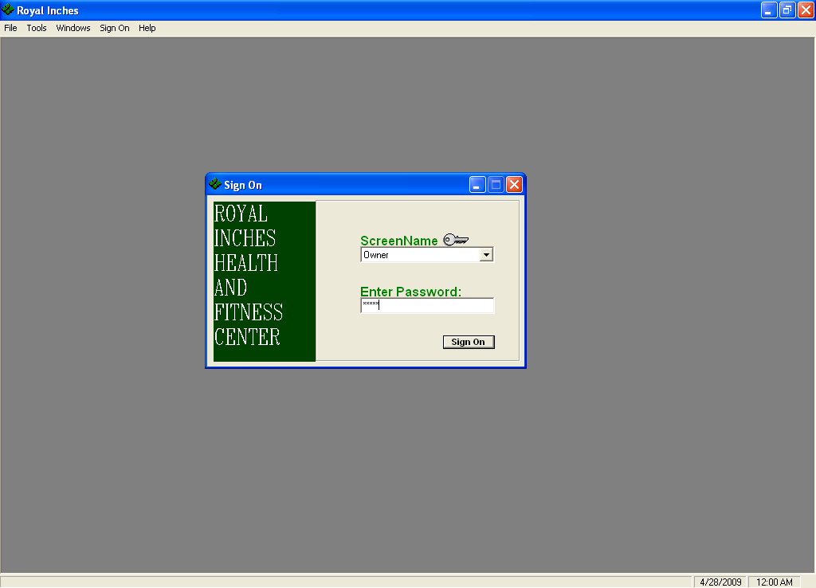

Menu Interface of the Fitness Club Management System(members tab selected)

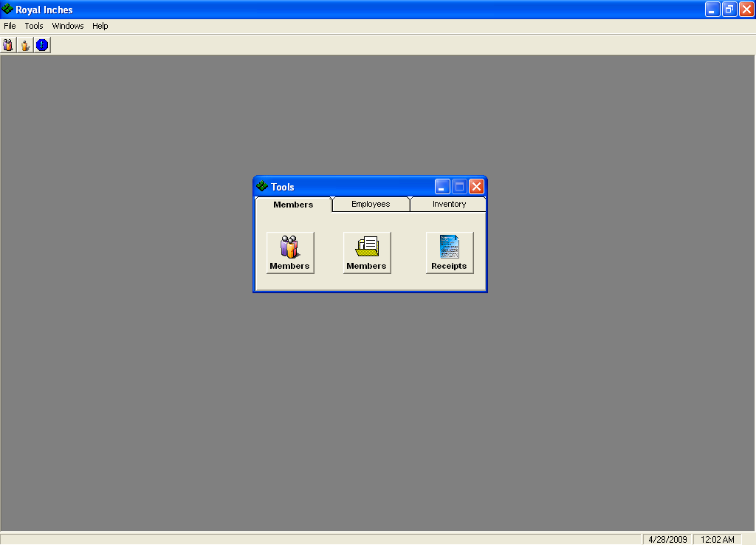
MEMBERSHIP FORM(AND DETAILS)

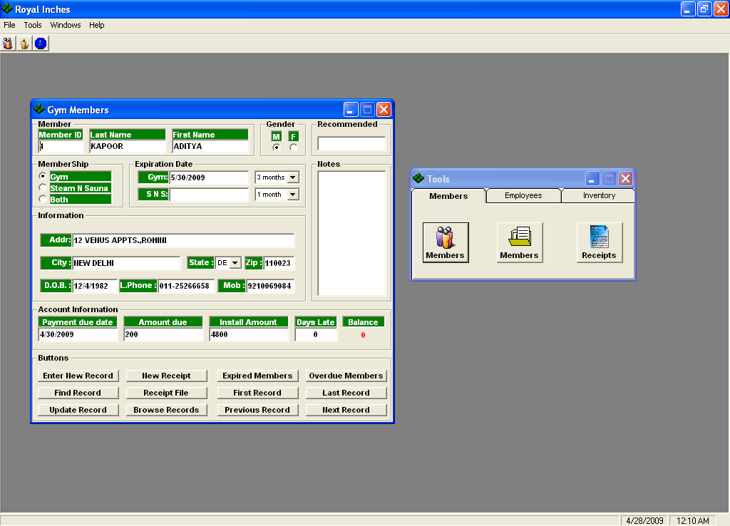

MEMBERSHIP RECORDS

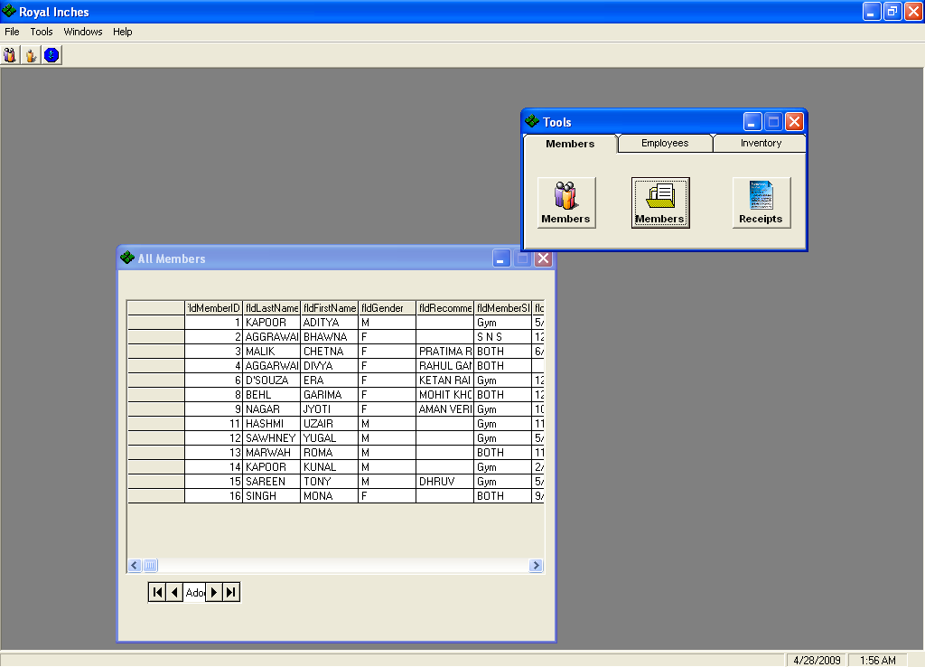
MEMBERSHIP RECIEPT

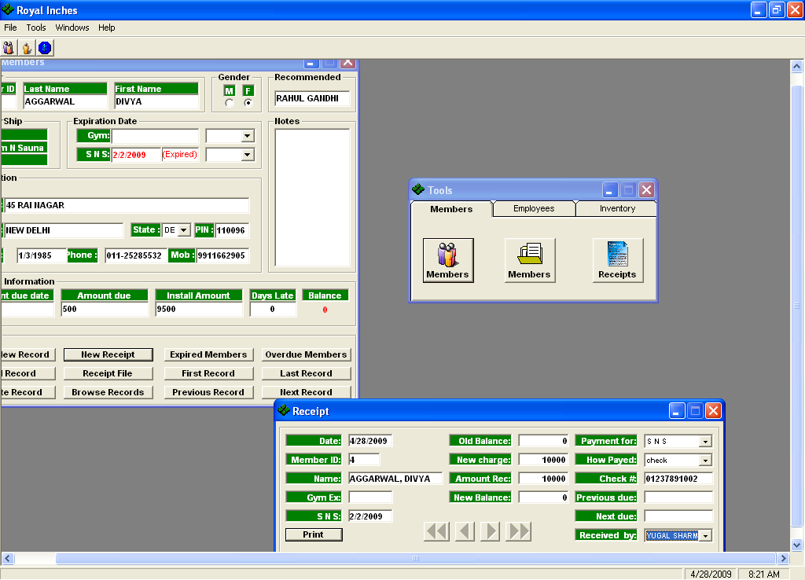

Menu Interface of the Fitness Club Management System(employees tab selected)

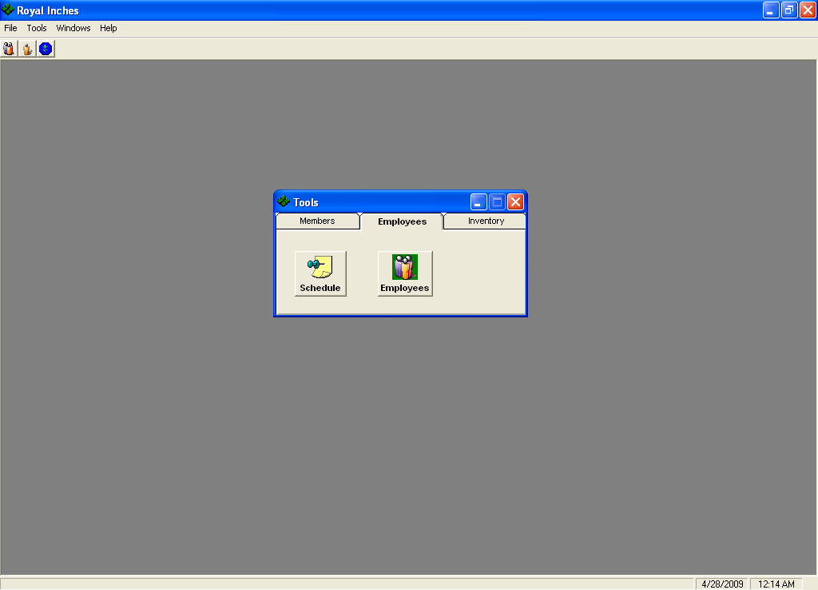

EMPLOYEE SCHEDULE
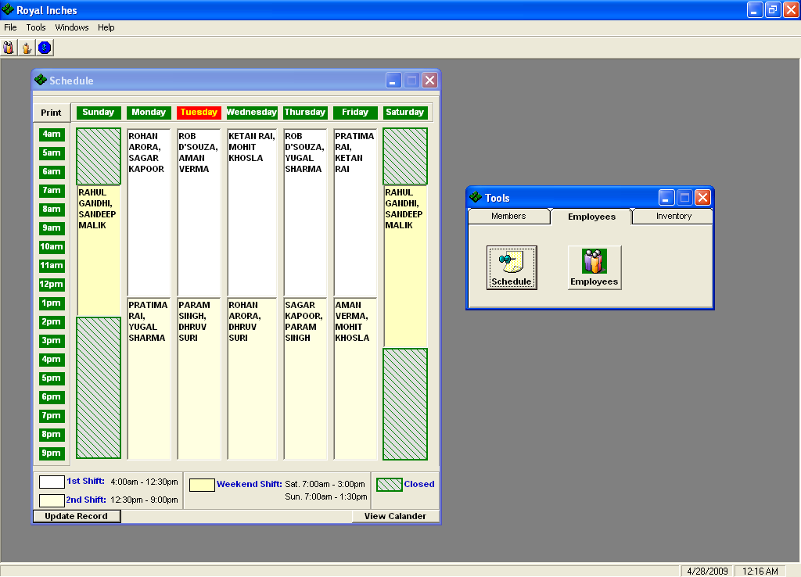

EMPLOYEE DETAILS FORM

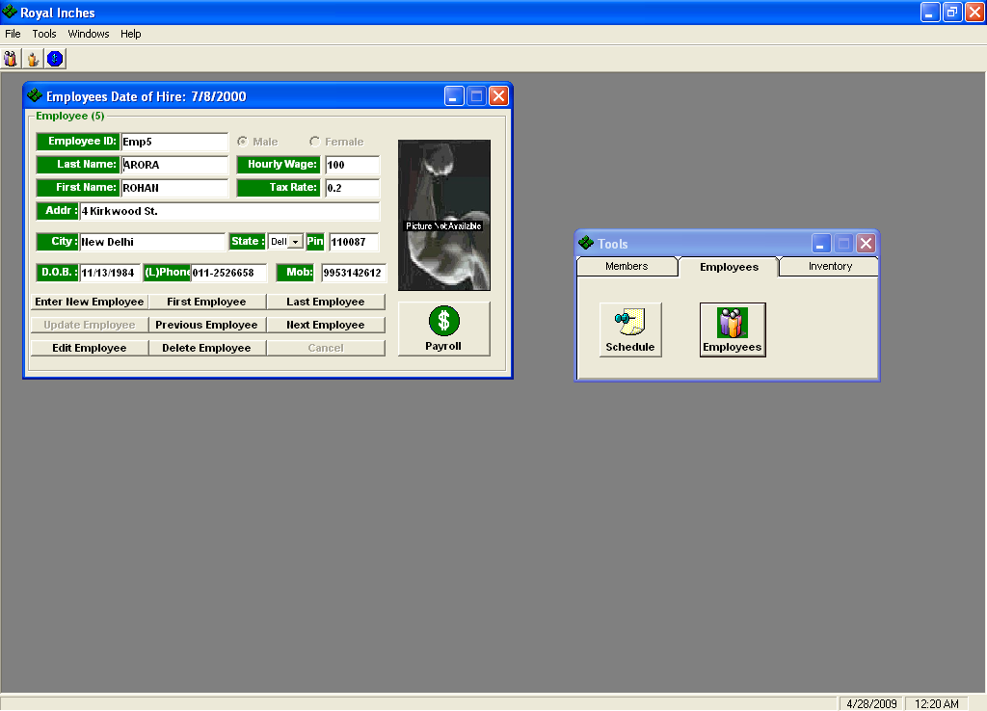
DELETING AN EMPLOYEE RECORD
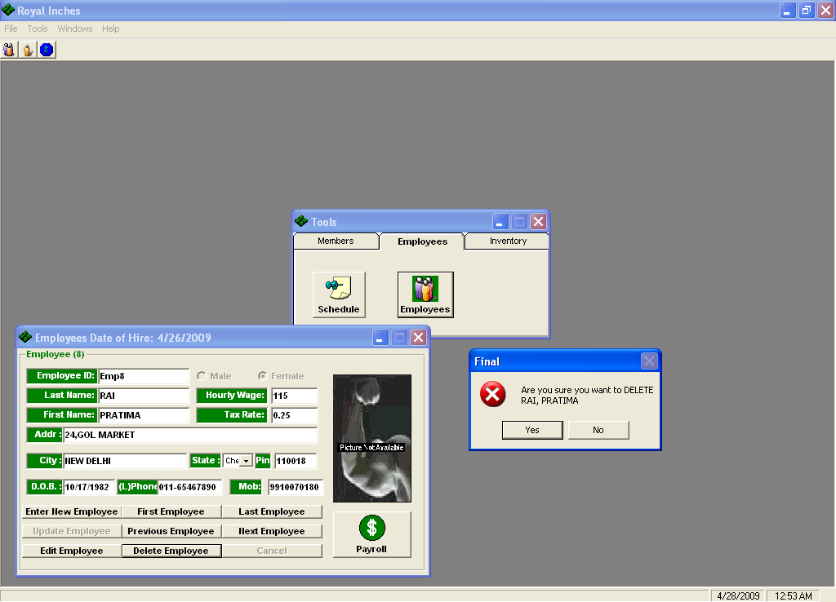

EMPLOYEE PAYROLL CALCULATION FORM

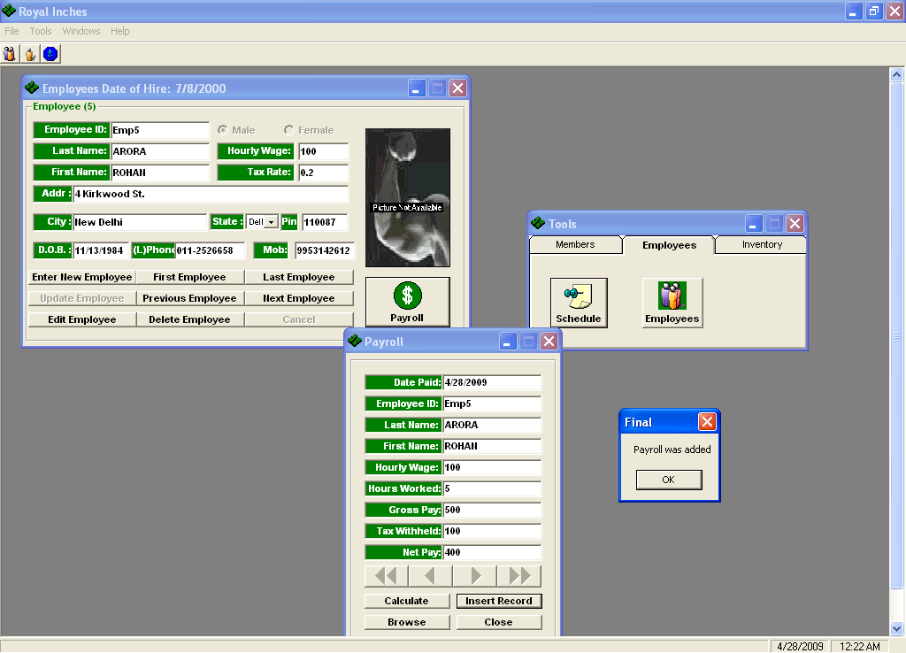

Menu Interface of the Fitness Club Management System(inventory tab selected)

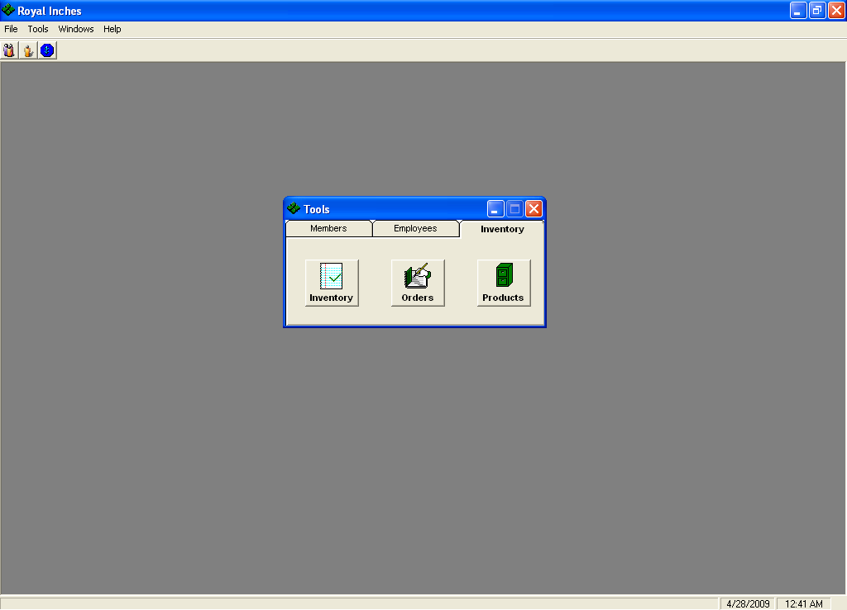
INVENTORY FORM

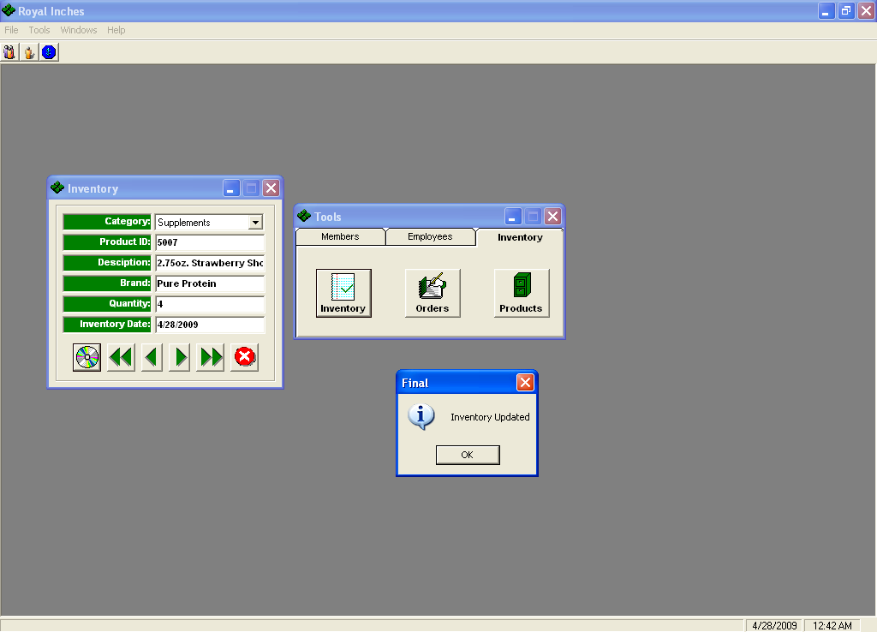

ORDER FORM
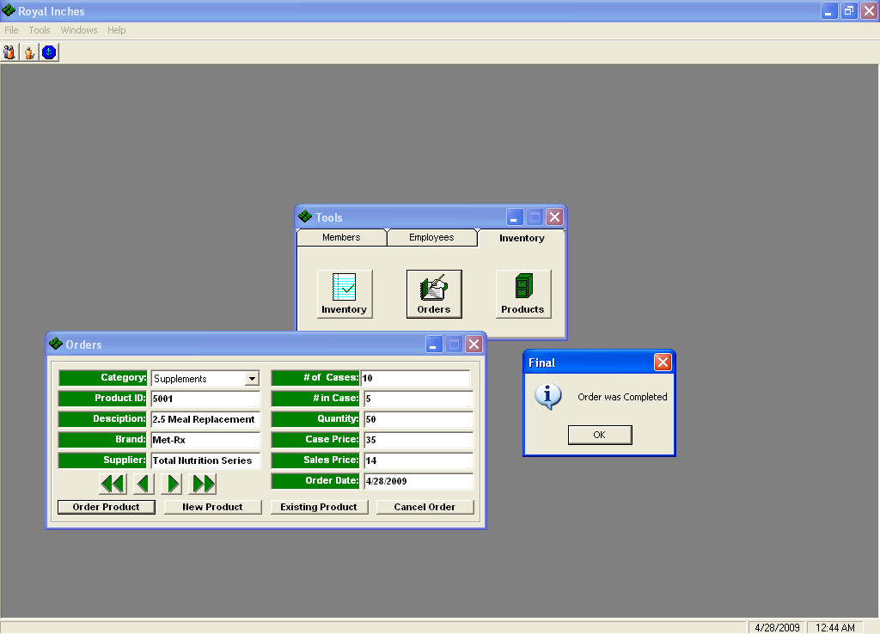

PRODUCT FORM

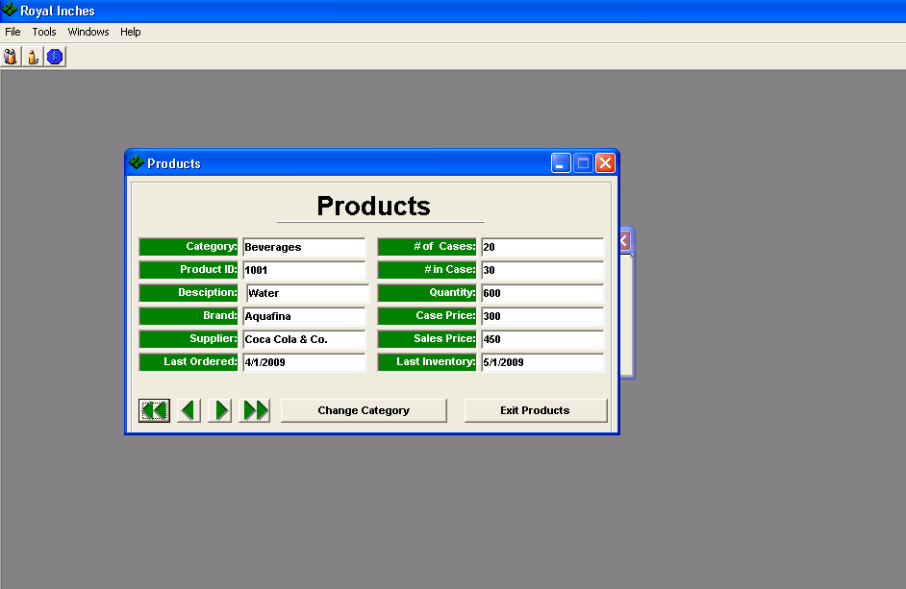

SECTION 8

TESTING
Levels of Testing:
Systems are not designed as entire systems nor are they tested as single systems. The analyst must perform both unit and system testing.

Unit Testing:
In unit testing the analyst tests the programs making up a system. For this reason, unit testing is sometimes called program testing. Unit testing gives stress on the modules independently of one another, to find errors. This helps the tester in detecting errors in coding and logic that are contained within that module alone. The errors resulting from the interaction between modules are initially avoided. The test cases needed for unit testing should exercise each condition and option.
Unit testing can be performed from the bottom up, starting with smallest and lowest-level modules and proceeding one at a time. For each module in bottom-up testing a short program is used to execute the module and provides the needed data, so that the module is asked to perform the way it will when embedded within the larger system.

System Testing:
The important and essential part of the system development phase, after designing and developing the software is system testing. We cannot say that every program or system design is perfect and because of lack of communication between the user and the designer, some error is there in the software development. The number and nature of errors in a newly designed system depend on some usual factors like communication between the user and the designer; the programmer's ability to generate a code that reflects exactly the systems specifications and the time frame for the design.

Theoretically, a newly designed system should have all the parts or sub-systems are in working order, but in reality, each sub-system works independently. This is the time to gather all the subsystem into one pool and test the whole system to determine whether it meets the user requirements. This is the last change to detect and correct errors before the system is installed for user acceptance testing. The purpose of system testing is to consider all the likely variations to which it will be subjected and then push the system to its limits.

Testing is an important function to the success of the system. System testing makes a logical assumption that if all the parts of the system are correct, the goal will be successfully activated. Another reason for system testing is its utility as a user-oriented vehicle before implementation.

System testing consists of the following five steps:

1) Program Testing
A program represents the logical elements of a system. For a program to run satisfactorily, it must compile and test data correctly and tie in properly with other programs. it is the responsibility of a programmer to have an error free program. At the time of testing the system, there exists two types of errors that should be checked. These errors are syntax and logic. A syntax error is a program statement that violates one or more rules of the language in which it is written. An improperly defined field dimension or omitted key words are common syntax errors. These errors are shown through error messages generated by the computer. A logic error, on the other hand, deals with incorrect data fields out of range items, and invalid combinations. Since the logical errors are not detected by compiler, the programmer must examine the output carefully to detect them.
When a program is tested, the actual output is compared with the expected output. When there is a discrepancy, the sequence of the instructions, must be traced to determine the problem. The process is facilitated by breaking the program down into self-contained portions, each of which can be checked at certain key points.

2) String Testing
Programs are invariably related to one another and interact in a total system. Each program is tested to see whether it conforms to related programs in the system. Each part of the system is tested against the entire module with both test and live data before the whole system is ready to be tested.

3) System Testing
System testing is designed to uncover weaknesses that were not found in earlier tests. This includes forced system failure and validation of total system as it will be implemented by its user in the operational environment. Under this testing, generally we take low volumes of transactions based on live data. This volume is increased until the maximum level for each transaction type is reached. The total system is also tested for recovery and fallback after various major failures to ensure that no data are lost during the emergency. All this is done with the old system still in operation. When we see that the proposed system is successful in the test, the old system is discontinued.

4) System Documentation
All design and test documentation should be well prepared and kept in the library for future reference. The library is the central location for maintenance of the new system.

5) User Acceptance Testing
An acceptance test has the objective of selling the user on the validity and reliability of the system. It verifies that the system's procedures operate to system specifications and that the integrity of important data is maintained. Performance of an acceptance test is actually the user's show. User motivation is very important for the successful performance of the system. After that a comprehensive test report is prepared. This report shows the system's tolerance, performance range, error rate and accuracy.

Special Systems Tests:
There are other six tests which fall under special category. They are described below:

- Peak Load Test: It determines whether the system will handle the volume of activities that occur when the system is at the peak of its processing demand. For example, test the system by activating all terminals at the same time.
- Storage Testing: It determines the capacity of the system to store transaction data on a disk or in other files. For example, verify documentation statements that the system will store 10,000 records of 400 bytes length on a single flexible disk.
- Performance Time Testing: it determines the length of time system used by the system to process transaction data. This test is conducted prior to implementation to determine how long it takes to get a response to an inquiry, make a backup copy of a file, or send a transmission and get a response.
- Recovery Testing: This testing determines the ability of user to recover data or re-start system after failure. For example, load backup copy of data and resume processing without data or integrity loss.
- Procedure Testing: It determines the clarity of documentation on operation and use of system by having users do exactly what manuals request. For example, powering down system at the end of week or responding to paper-out light on printer.
- Human Factors Testing: It determines how users will use the system when processing data or preparing reports.

SECTION 9

IMPLEMENTATION

9.1 Hardware Requirement

9.2 Software Requirement
After completing the packaging process and produced distribution media for the application, The application requires perfectly working Microsoft Visual Studio 6.0 installed on the client system along with Ms Offfice Access. It can run on all applicable operating systems.

8.1 Hardware Requirement
Hardware is the term given to machinery itself and to various individual pieces of equipment. It refers to the physical devices of a computer system. Thus the input, storage, processing control and output devices are hardware.
Minimum Hardware Requirement Of Client Side:
Processor: Any Pentium or Equivalent Machine
RAM: 256 MB
HDD: 1.2 GB
CD-ROM: 32X
14 inches Color Monitor
104 Keys Keyboards
Printer: DeskJet 670 C

8.2 Software Requirement

Software means a collection of program where the objective is to enhance the capabilities of the hardware machine.
Minimum Software Requirement Of Client Side:
Operating System : Windows 9x/NT/2000/Xp
Database : Microsoft Office Access

Front-end : Visual Basic 6.0

IMPLEMENTATION

Once the system was tested, the implementation phase started. A crucial phase in the system development life cycle is successful implementation of new system design. Implementations simply mean converting new system design into operation. This is the moment of truth the first question that strikes in every one’s mind that whether the system will be able to give all the desires results as expected from system. The implementation phase is concerned with user training and file conversion.
The term implementation has different meanings, ranging from the conversion of a basic application to a complete replacement of computer system Implementation is used here to mean the process of converting a new or revised system design into an operational one. Conversion is one aspect of implementation. The other aspects are the post implementation review and software maintainence. There are three types of implementation:

- Implementation of a computer system to replace a manual system
- Implementation of a new computer system to replace an existing one.
- Implementation of a modified application to replace an existing one.

Conversion

Conversion means changing from one system to another. The objective is to put the tested system into operation while holding costs, risks and personnel irritation to a minimum. It involves creating computer compatible files; training the operational staff; installing terminals and hardware. A critical aspect of conversion is not disrupting the functioning of organization.

Direct Implementation

In direct implementation; the previous system is stopped and new system is started up coincidentally. Here there is a direct change over from manual system to computer-based system. In direct change over implementation; employess can face the problems. Suppose our software is not working much efficiently as manual one then we can’t find the defects in our software. It will not be beneficial in finding errors.

The proposed system is fully implemented using Direct Implementation.

SECTION 10

MAINTAINENCE
MAINTENANCE

Once the software is delivered and developed, it enters the maintenance phase. All systems need maintenance. Software needs to be maintained because there are often some residual errors or bugs remaining in the system that must be removed as they are discovered. Many of these surfaces only after the system has been in operation sometimes for a long time. These errors once discovered need to be removed, leading to the software getting changed. Though Maintenance is not a part of software development, it is an extremely important activity in the life of a software product.

Maintenance involves understanding the existing software (code and related documents), understanding the effects of change, making the changes-to both the code and documents-testing the new parts and retesting the old part.

SECTION 11

CONCLUSION
The objective of this project was to build a program for maintaining the details of all the members,employees and inventory .The system developed is able to meet all the basic requirements. The management of the records (both members and employees)will be also benefited by the proposed system, as it will automate the whole procedure, which will reduce the workload. The security of the system is also one of the prime concerns.

There is always a room for improvement in any software, however efficient the system may be. The important thing is that the system should be flexible enough for future modifications. The system has been factored into different modules to make system adapt to the further changes. Every effort has been made to cover all user requirements and make it user friendly.

- Goal achieved: The System is able provide the interface to the owner so that he can replicate his desired data. .

- User friendliness: Though the most part of the system is supposed to act in the background, efforts have been made to make the foreground interaction with user(owner) as smooth as possible. Also the integration of the existing system with the project has been kept in mind throughout the development phase.

SECTION 12

BIBLIOGRAPHY
Bibliography

- www.wikipedia.org
- www.codeproject.com
- Visual Basic 6.0 Resource Center | http://msdn.microsoft.com/hi-in/vbrun/default(en-us).aspx
- Visual Basic 6 Black Book By Steven Holzner

